United Federal Credit Union – Press Release
December 19, 2022

Contact: Diana Wake
Phone: (888) 982-1400 ext. 6891
Email: dwake@UnitedFCU.com
United Federal Credit Union, 150 Hilltop Road, St. Joseph, Michigan, 49085

United Federal Credit Union Mortgage Advisor Named ‘Affiliate of the Year’

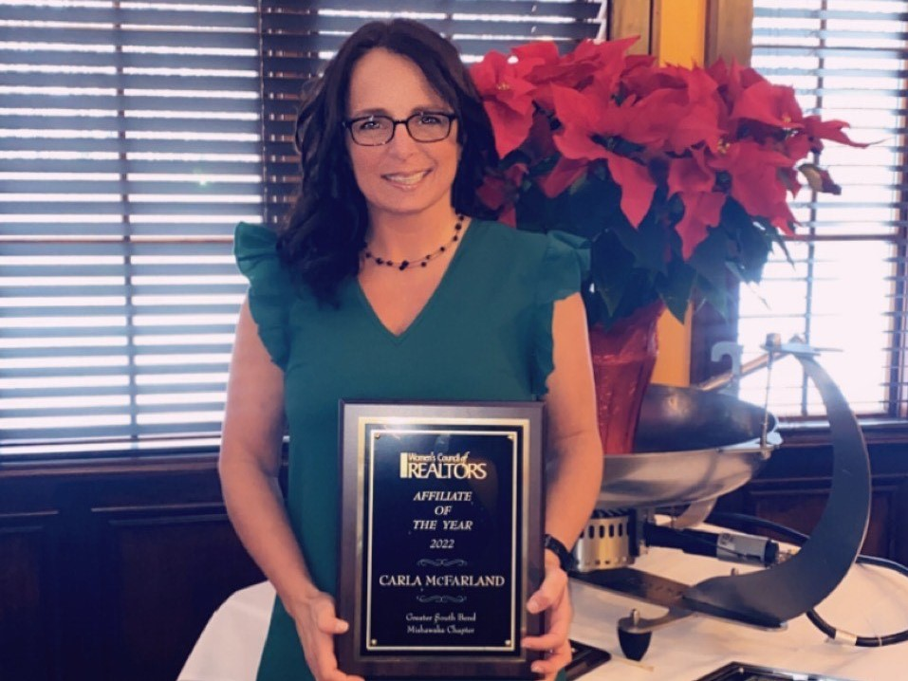
Carla McFarland with her award from the Women’s Council of Realtors

MISHAWAKA, Ind. – United Federal Credit Union (United) Mortgage Advisor, Carla McFarland, has been named ‘Affiliate of the Year’ by the Women’s Council of Realtors Greater South Bend.

“I love having the opportunity to help within our community to promote realtors, businesses, and organizations that help make this area a better place to live,” said McFarland. “One of the best parts of my job is working with our Members to find them the mortgage loan option that will help make their home ownership dreams come true!”

The ‘Affiliate of the Year’ award is voted on by all the members of the Women’s Council of Realtors. It is given to the affiliate who goes above and beyond throughout the year with events, monthly meetings, and is the person who steps up when needed.

McFarland has worked for United for more than three years. She is currently based at its Edison Lakes branch in Mishawaka.

“Carla works tirelessly to be a valued resource for United and our Members,” said Brett Wier, Director of Mortgage Production-Midwest. “In addition to the great work she does with United, she invests significant time into our community as a volunteer and has a passion for giving back. We are incredibly proud of Carla and this achievement. This recognition is well deserved.”
____________
About United
United Federal Credit Union has served its Members since 1949 by helping them to build a sound financial future. United consists of more than 191,000 Member/owners worldwide and manages assets in excess of $3.8 billion. Its corporate office and main branch are in St. Joseph, Mich., with additional branches in Arkansas, Indiana, Michigan, Nevada, North Carolina, and Ohio. Federally insured by NCUA. Equal opportunity lender. Equal housing lender. For more information visit UnitedFCU.com

# # #

