FOR IMMEDIATE RELEASE
Contact:
Aaron Geller
Marketing & Brand Manager
720-945-7250 or ageller@auxteam.com

C-suite and other Leadership Changes at Back-office CUSO Aux
LAKEWOOD, Colorado (January 11, 2023) – Back-office support CUSO Aux announces the following changes in leadership.
Gaye DeCesare, Aux VP Compliance, has been appointed Chief Compliance Officer and Alan Bergstrom, Aux VP Marketing & Business Development, has been appointed Chief Marketing Officer, both effective January 1, 2023.
DeCesare joined Aux 2017, following Aux’s acquisition of Compass 4 CUs where DeCesare had been that CUSO’s VP of Compliance Services. Bergstrom joined Aux in 2021 after having served as CEO of Exclamation Services CUSO.
Additionally, Holla Walker will become Aux CFO when Diane Parham becomes CEO on April 1, 2023. Parham had been Aux CFO since 2019. Parham is succeeding Doug Burke who is retiring as Aux CEO on March 31, 2023. Walker is currently serving as a CFO Consultant at Aux.
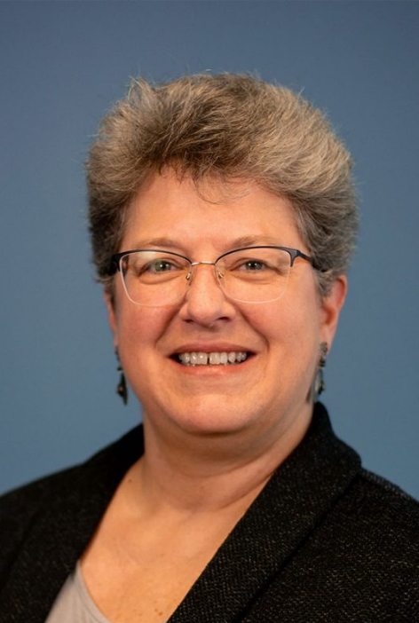
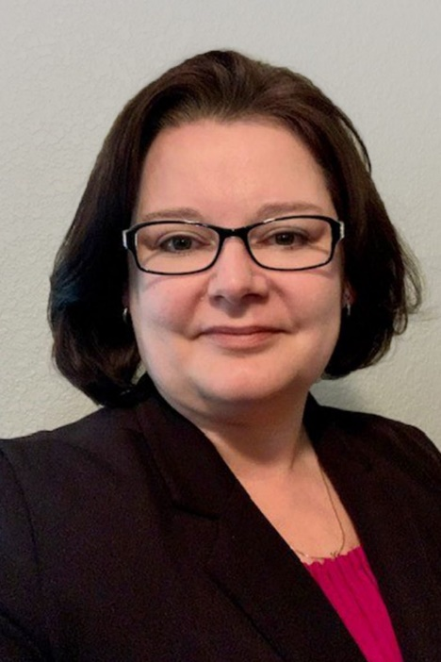
Gaye DeCesare Alan Bergstrom Holla Walker

Several other promotions have also been announced by Aux. Within the Accounting Services team, Patty Simons and Michael Giacalone have both been promoted to VP of Accounting, and Oscar Dixon was promoted to Controller. Within the Compliance Services team, Jason Clarke was promoted to Senior Compliance Officer and Imani Najee-Ullah was promoted to Compliance Specialist I. On the Corporate team, Monica Williams was promoted to Manager of Learning & Development.

ABOUT AUX
Aux, established in 1992, is a Credit Union Service Organization (CUSO) owned by 53 credit unions, and serves over 100 credit union clients. We provide a variety of progressive back-office solutions that drive credit union success, including accounting and compliance. We are leaders in credit union innovation, cooperation and research. We do the hard work for you. We are Aux Team proud. For more information on Aux, please visit us at auxteam.com or contact us at (720) 945-7250.

