United Federal Credit Union – Press Release
January 6, 2023

Contact: Matt Orlando
Phone: (888) 982-1400 ext. 1473
Email: morlando@unitedfcu.com
United Federal Credit Union, 150 Hilltop Road, St. Joseph, MI 49085

United Announces Key Leadership Promotions to Kickoff New Year

ST. JOSEPH, Mich. – United Federal Credit Union (United) in St. Joseph, Michigan announced the promotion of two current employees to key leadership roles in 2023. The appointments include expanded roles at the credit union at the senior leadership level, and in the Midwest region.

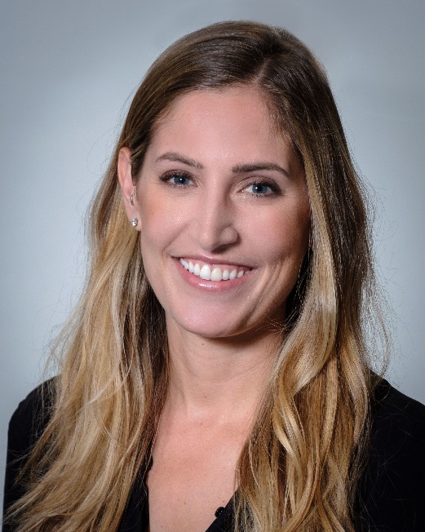

Kaylee Ganus, Chief Marketing Officer

Kaylee Ganus has been promoted to the position of Chief Marketing Officer. In her new role, Ganus will continue to provide operational and strategic leadership to the marketing and product development teams, and lead the credit union’s strategic vision relating to the corporate image, branding, digital strategy, communications, and community impact throughout United’s six-state footprint.
.
Since joining United in 2020 as Senior Vice President of Marketing, Ganus has overseen and helped implement marketing and communication initiatives that have resulted in credit union growth and increased Member loyalty and engagement. She was pivotal in developing the communication and change management plans that led employees and Members through acquisitions in Michigan and Arkansas, major system upgrades including a core and card processor conversion, and an overhaul to the credit union’s approach to overdraft fees.

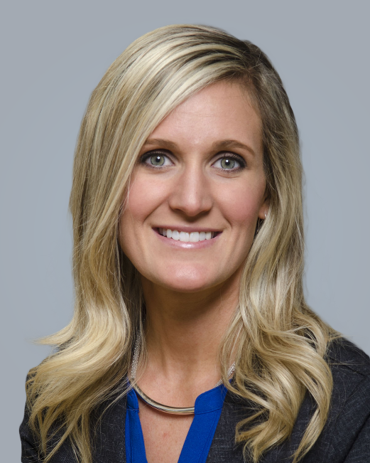

Jodie Kitchell, Regional Vice President—Indiana, Michigan

Jodie Kitchell has been appointed to the position of Regional Vice President, serving the Indiana and Michigan markets. Kitchell brings more than 11 years of credit union and member service experience to her new role, as well as a passion for building community relationships. As Regional Vice President, she will develop and execute integrated marketplace business and marketing plans driving sales, service and business development initiatives to achieve market growth aligned with strategic business objectives.

Kitchell joined United in 2011, and was named Branch Manager at the South State Street branch in St. Joseph, Michigan in 2017. She was promoted in 2019 to Regional Market Development Manager serving North Berrien County, Michigan where she was responsible for driving business development, promoting corporate member engagement, growing business and consumer membership, and recruiting members in both new and existing markets. Kitchell was named to her most recent role as District Manager in January 2022.

In the community, Kitchell is an active volunteer in a number of organizations like Junior Achievement, Girls on the Run of Southwest Michigan, and the United Way of Southwest Michigan. She was named to Moody on the Market’s “40 Under 40” class in 2020 in recognition of her professional accomplishments, leadership, and inspiration to others.

“We have seen how the strength and dedication from Kaylee and Jodie have helped push United to improve the lives of our members for the last several years,” said United President/CEO Terry O’Rourke. “I am thankful for their leadership, and know as they move into these roles and inspire teams across the credit union we will be able to deliver the best experiences possible to members and the communities we serve.”
____________
About United
United Federal Credit Union has served its Members since 1949 by helping them to build a sound financial future. United consists of more than 191,000 Member/owners worldwide and manages assets in excess of $3.9 billion. Its corporate office and main branch are in St. Joseph, Mich., with additional branches in Arkansas, Indiana, Michigan, Nevada, North Carolina, and Ohio. Federally insured by NCUA. Equal opportunity lender. Equal housing lender. For more information visit www.unitedfcu.com

# # #

