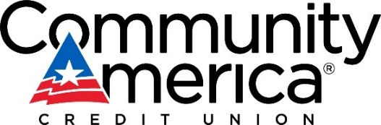

Media Contact: Amanda Turk
Manager, Corporate Communications
913-905-8254
aturk@cacu.com

FOR IMMEDIATE RELEASE:

COMMUNITYAMERICA ANNOUNCES RECORD-BREAKING
PROFIT PAYOUT

Lenexa, Kan. (January 11, 2023) – Kansas City-based CommunityAmerica Credit Union is pleased to announce they will be returning a record-breaking $9.5 million back to their members through their Profit Payout program.
“We have such a heart for serving our members and our community, so it’s truly important that we are good stewards of our business and well positioned to pay forward a portion of our profit to them,” said CommunityAmerica CEO Lisa Ginter. “Working hard for our members and the communities we serve is what drives us and allows us to deliver this kind of return!”
This year’s $9.5 million Profit Payout follows last year’s record of $9 million.
CommunityAmerica Credit Union is a not-for-profit institution which means profits are returned to their members through various incentives and programs. The Profit Payout program is a dividend that allows CommunityAmerica to share a portion of their profits with their members. Members who qualify for the Profit Payout program need to be considered highly engaged in three of six categories (Save, Spend, Manage, Borrow, Live and Invest). For more information about the Profit Payout program, visit this link.
About CommunityAmerica Credit Union
CommunityAmerica Credit Union is a full-service financial institution with more than 260,000 member-owners nationwide and more than $4.6 billion in assets, ranking it among the nation’s 100 largest credit unions. Based on deposits, CommunityAmerica is among the top 10 Kansas City-based financial institutions and repeatedly named a ‘Best Place to Work’ in Kansas City by the Kansas City Business Journal. There are more than 30 CommunityAmerica branches in the greater Kansas City metro area, and one in St. Louis.
CommunityAmerica serves individuals and businesses, providing a full suite of financial products and services ranging from checking and savings to a variety of loan products to commercial banking. They also offer wealth management, retirement planning, private banking and insurance. CommunityAmerica is among the top mortgage providers in Kansas City based on loan volume. Its commitment to state-of-the-art technology enables a seamless banking experience for members, whether banking in branches or remotely. As a not-for-profit financial institution, CommunityAmerica offers highly competitive rates on deposits, loans and fees with fewer, lower or none at all. Other convenient products and services include Sunday hours, a network of more than 30,000 ATMs, 24-hour online banking and a top-rated mobile banking app. Want to become a member? You simply need to live in the Kansas City metropolitan area or have family members who do. For more information, visit www.communityamerica.com.
# # #

