United Federal Credit Union – Press Release
February 15, 2022

Contact: Diana Wake
Phone: (888) 982-1400 ext. 6891
Email: dwake@UnitedFCU.com
United Federal Credit Union, 150 Hilltop Road, St. Joseph, Michigan, 49085

United Federal Credit Union Promotes Juan De Alba Villegas Branch Manager at Carson City North Branch

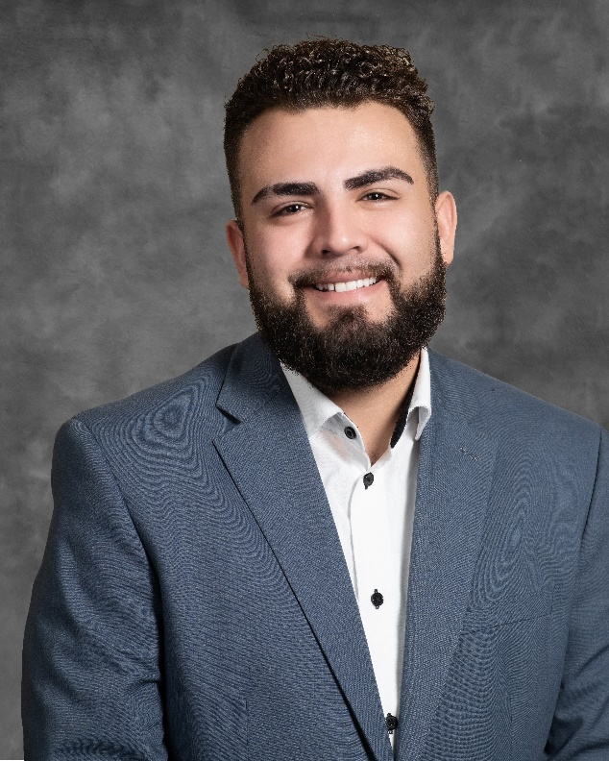
Juan De Alba Villegas, Branch Manager, Carson City North

CARSON CITY, Nev. – United Federal Credit Union (United) has promoted Juan De Alba Villegas to the position of Branch Manager at its location at 1350 E. William St. in Carson City, Nevada.

As Branch Manager, De Alba Villegas will be responsible for maintaining the performance of the branch, and providing leadership and supervision to staff.

De Alba Villegas brings nearly five years of financial and management experience to his new role. He has been with United since 2019. Prior to becoming Branch Manager, De Alba Villegas was a Member Service Advisor at United’s Bible Way Branch in Reno.

De Alba Villegas is active in the community and has been involved with Big Brothers Big Sister of America for three years. He looks forward to continue supporting United’s community impact efforts with organizations including United Way of Norther Nevada, the Boys and Girls Club of Truckee Meadows and other non-profits.

____________
About United
United Federal Credit Union has served its Members since 1949 by helping them to build a sound financial future. United consists of more than 186,000 Member/owners worldwide and manages assets in excess of $3.8 billion. Its corporate office and main branch are in St. Joseph, Mich., with additional branches in Arkansas, Indiana, Michigan, Nevada, North Carolina, and Ohio. Federally insured by NCUA. Equal opportunity lender. Equal housing lender. For more information visit UnitedFCU.com

# # #

