



**Greater Texas|Aggieland’s Greater Good Campaign Increased Community Service in 2022**

**Austin, Texas, Feb. 22, 2023** – [Greater Texas|Aggieland Credit Union](http://www.gtfcu.org) donated nearly $200,000 to charities in Central Texas, the Brazos Valley and other service areas of Texas last year. The donations were part of the credit union’s Greater Good campaign, a corporate-wide initiative to increase community service and engagement.

In addition to monetary donations, credit union employees devoted more than 1,000 hours of volunteer time to serve and support local causes. Greater Texas offers employees 16 hours a year of paid time to participate in community volunteer activities. Many employees far exceeded that amount of volunteer time.

The Greater Good 2022 campaign focused on several large projects benefiting the Austin Habitat for Humanity, Austin Disaster Relief Network, Any Baby Can, Aggie Moms, Ronald McDonald House of Charities of Central Texas, and the Brazos Valley Voices for Children.



A group of Greater Texas employees joined other credit union professionals for a collaborative building project for the 3rd annual House that Credit Unions Built with the Austin Habitat for Humanity. Working together, the group helped build a home that will be made available at an affordable cost for a deserving family in need.

Greater Texas also worked closely with the Austin Disaster Relief Network to provide 10 employee volunteers a month to help the charity with on-site support at its operations facility, as well as in the field assisting survivors of natural disasters.

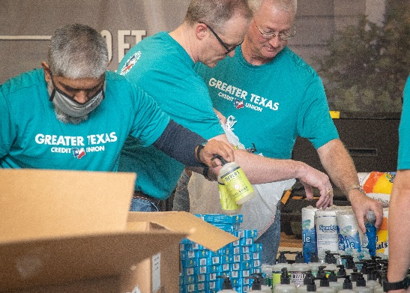“Greater Good is about doing the right thing for those in need,” said Howard Baker, CEO of Greater Texas|Aggieland Credit Union. “The initiative allows us to focus on causes that support some of the most vulnerable people in our communities, helping to ease their burden and offer them hope.”

**About Greater Texas Credit Union**

[Greater Texas](http://www.gtfcu.org) Credit Union, founded in 1952, is a financial cooperative that emphasizes community stewardship, charitable giving, and employee volunteerism through its Greater Good initiative. Together with its subsidiary, Aggieland Credit Union – which serves the Brazos Valley – the credit union offers a wide variety of consumer-oriented banking services to its 80,000 members across the state of Texas. Greater Texas has locations in Austin, Houston, San Antonio, Bryan-College Station, Edinburg, and the Dallas-Ft. Worth market with assets of nearly $1 billion.

###