



**Greater Texas Credit Union Signs Multi-year**

**Sponsorship with Texas State University Sports**

**Austin, Texas, March 9, 2023** – [Greater Texas Credit Union](http://www.gtfcu.org) and Texas State University have signed a multi-year sponsorship agreement making Greater Texas an official sponsor of [Texas State Athletics](https://txst.com/).

Texas State University, in San Marcos, is one of the largest universities in the state offering both undergraduate and graduate programs. The competitive athletics program for men and women includes football, baseball, basketball, soccer, track and field, tennis, softball, volleyball, golf, and more. Texas State is part of the Sun Belt Conference.

Bucky Lamb, General Manager for Texas State Sports Properties, negotiated the agreement with Greater Texas. “We are thrilled to partner with Greater Texas Credit Union as an official sponsor and a part of the Bobcat family. Greater Texas is already a loyal supporter of Texas State University. We are excited the credit union continues to choose Texas State as a strategic partner as they expand their brand in San Marcos and beyond.”

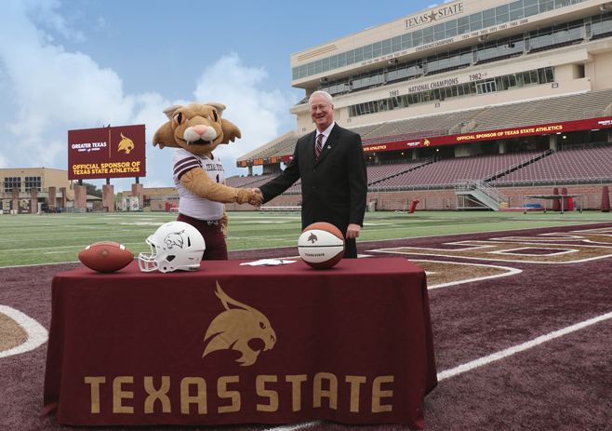With the agreement, Greater Texas has usage rights for the Texas State logo and the image of Boko the Bobcat, the university’s mascot. The credit union will also maximize an array of marketing and promotional opportunities covering all the men’s and women’s athletic teams. Greater Texas will host onsite activities and initiatives during select sponsored games. Plus, as the presenting sponsor of the Bobcat Kids Club, the credit union is investing in the future at Texas State University.

“Greater Texas is ecstatic with our new partnership agreement that takes the credit union’s support of Texas State University faculty, staff, and students to the next level,” said Howard Baker, President and CEO of Greater Texas. “We already support the university through an endowment and financial support of athletics and on-campus activities. We look forward to new opportunities to connect with the Bobcat community with much greater frequency to improve members’ financial well-being, providing the best banking experiences, and supporting the growth and influence of Texas State University.”

The four-year agreement also covers stadium/field signage, game time video and program announcements, digital exposure on campus screens, and the official [Bobcat website](http://www.TXST.com).

“We are extremely grateful for the partnership with Greater Texas Credit Union. Their choice to help support our pursuit of championships and developing champions, in competition and in life, creates an important strategic partnership for all of Bobcat Nation,” said Don Coryell, Texas State University Director of Athletics. “I look forward to seeing their name at our facilities and on our website as well as being the presenting sponsor of our Bobcat Kids Club.”

**About Greater Texas Credit Union**

[Greater Texas](http://www.gtfcu.org) Credit Union, founded in 1952, is a financial cooperative that emphasizes community stewardship, charitable giving, and employee volunteerism through its Greater Good initiative. Together with its subsidiary, Aggieland Credit Union – which serves the Brazos Valley – the credit union offers a wide variety of consumer-oriented banking services to its 80,000 members across the state of Texas. Greater Texas has locations in Austin, Houston, San Antonio, Bryan-College Station, Edinburg, and the Dallas-Ft. Worth market with assets of nearly $1 billion.

###