



**Greater Texas Credit Union Funds ‘Little Lockers’**

**at Elementary Schools to Encourage Reading**

**Austin, Texas, March 16, 2023** – [Greater Texas Credit Union](http://www.gtfcu.org) has partnered with the TEXAS YES Project to provide Little Lockers at elementary schools in the Manor Independent School District.

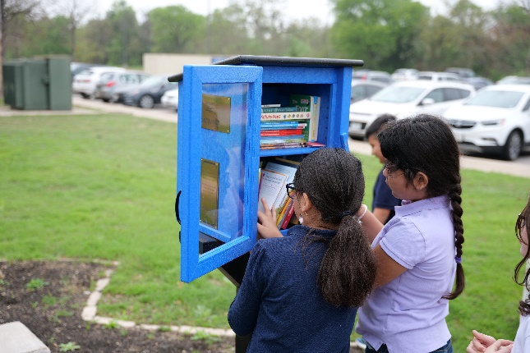Little Lockers are stocked with new books and activities that children can access anytime. The brightly colored blue waterproof cabinets were installed outside of Oak Meadows, Presidential Meadows, and Blake Manor Elementary schools to make their contents accessible to children and the community year-round.

The [TEXAS YES Project](https://www.texasyesproject.org/) conceived the idea as a tool to help improve literacy and make books more accessible in communities without a local library. The group oversees the installation of the lockers and ensures each is stocked throughout the year with an array of books for school-aged children.

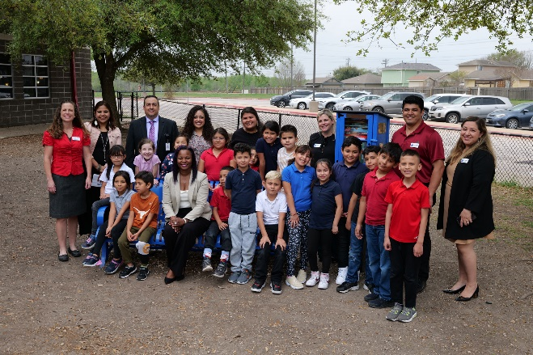Manor elementary schools are the first in Central Texas to receive the lockers. Manor’s Little Lockers were presented to the three schools by Greater Texas Credit Union, which funded the initiative.

KVUE, the ABC affiliate in Austin, Texas covered the [unveiling of the Little Lockers](https://www.kvue.com/video/news/education/little-libraries-are-being-placed-at-manor-isd-schools-to-increase-access-to-books/269-376012be-861d-427e-a6f1-0c33131a6881), speaking with Rachel Bond, Assistant Vice President ofCommunity Engagement and Public Relations about the credit union’s involvement in the project.

As Bond said, “The idea of Little Lockers is to help encourage children to read and discover new things. These lockers are a great community resource that we hope will increase the children’s desire to read.”

**About Greater Texas Credit Union**

[Greater Texas](http://www.gtfcu.org) Credit Union, founded in 1952, is a financial cooperative that emphasizes community stewardship, charitable giving, and employee volunteerism through its Greater Good initiative. Together with its subsidiary, Aggieland Credit Union – which serves the Brazos Valley – the credit union offers a wide variety of consumer-oriented banking services to its 80,000 members across the state of Texas. Greater Texas has locations in Austin, Houston, San Antonio, Bryan-College Station, Edinburg, and the Dallas-Ft. Worth market with assets of nearly $1 billion.

###