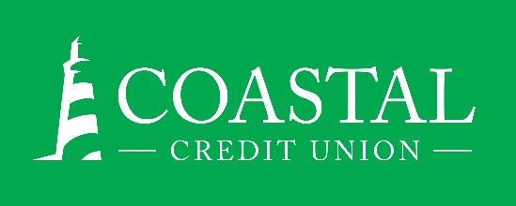
NEWS RELEASE
Contact: Joe Mecca
VP, Communication / Spokesperson
919-420-8044 /jmecca@coastal24.com
FINAL – For Immediate Release

Coastal Credit Union Foundation Funds Two Habitat for Humanity Builds in Honor of Retiring CEO Chuck Purvis
RALEIGH, N.C. (March 16, 2023) – The Coastal Credit Union Foundation has granted $100,000 each to Habitat for Humanity of Orange County and Habitat for Humanity of Durham County to fund the building of two homes in honor of Coastal’s retiring CEO, Chuck Purvis and his wife, Gail Purvis.

“We have the opportunity to help families realize their dreams of having their own home for the first time,” said Creighton Blackwell, Chief Community Impact and Public Affairs Officer, Coastal Credit Union. “With the Chuck and Gail Purvis houses in Orange and Durham Counties, we honor the legacy of Chuck Purvis and the impact he has had on Coastal, and the communities we serve.”

The Habitat for Humanity of Orange County house was dedicated on Wednesday, March 15, 2023, and the Durham County house is being dedicated on Friday, April 14, 2023.

“My mission as CEO of Coastal has always been to serve our members, and the communities where we work, said Purvis. “Gail and I are honored to be a part of giving back to the community in a tangible way.”

The Coastal foundation works to enrich the lives of members and their communities by impacting four key areas: promoting financial well-being, increasing affordable housing, supporting financial education, and improving access to resources. The foundation does this by providing financial support to 501(c)(3) organizations, primarily those serving Coastal’s 16-county footprint in central North Carolina.

The Habitat for Humanity grants are part of the Foundation program that awards grants in Coastal’s 16-county footprint in central North Carolina.

The Coastal Foundation’s other grantees for our first quarter include:
- Boys and Girls Club of Durham and Orange County
- WNC Digital Bridge
- Dunn Police Activities League (Micro Grant)
- NC Center for Employee Ownership
- Refugee Community Project

About the Coastal Credit Union Foundation
The Coastal Credit Union Foundation is a separate entity from the credit union. The mission of the Foundation is to enrich the lives of our members and their communities by providing financial support to 501(c)(3) organizations, particularly in the 16-county market of central North Carolina
About Coastal
Coastal Credit Union is a not-for-profit, member-owned, financial cooperative, offering a full range of financial products and services. Coastal was chartered on August 31, 1967 with the mission of fostering the credit union philosophy of “people helping people.” Today, with $4.6 billion in assets, Coastal serves 323,000 members from 1,800 business partners and is among the leading financial institutions in North Carolina. Coastal operates 23 branches in central North Carolina and serves members in all 50 states through a network of 5,500 shared branches, 30,000 surcharge-free ATMs, mobile banking featuring mobile check deposit, and a robust offering of online services at www.COASTAL24.com. For more Coastal news, visit our online newsroom.

###

.

