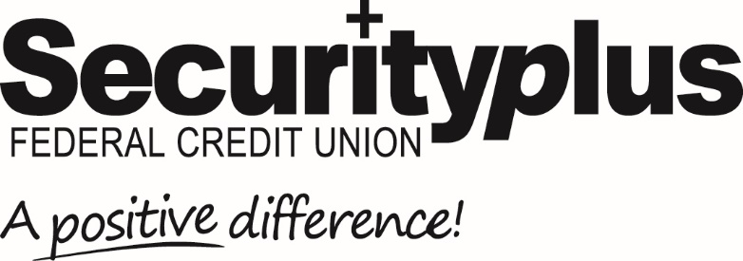

For Release: Immediate Contact: Lisa Allender
410-281-6248
lisa.allender@securityplusfcu.org

Securityplus Federal Credit Union Announces
Merger with Mount Lebanon Federal Credit Union

Baltimore, MD (March 1, 2023) Securityplus Federal Credit Union, headquartered in Baltimore, Maryland announced the successful merger of Mount Lebanon Federal Credit Union (MLFCU) with its Credit Union.
MLFCU with approximately 190 members, was founded in 1970 as a religious-based credit union located in Baltimore City at Mount Lebanon Baptist Church. Former President and CEO, Barbara Casey, announced that the Credit Union would become part of Securityplus, effective December 31, 2022, and its sole branch location would close in mid-February.
“We are excited to welcome our new members from MLFCU,” stated Chief Executive Officer Tricia Szurgot, “and pleased that we can offer them enhanced products, services, access, and education to help make a positive difference for them and their families.”

As a result of the merger, former MLFCU members will benefit from additional banking services and products, including online and mobile banking, access to a nationally based network of ATMs, free checking, home mortgages, financial education, and more.

Securityplus Federal Credit Union is a $550⁺ million not-for-profit, member-owned, financial institution serving the Greater Baltimore Area and beyond. Founded in 1938, Securityplus is one of Maryland’s largest full-service credit unions, with over 34,000 members. With a focus on making a positive difference, Securityplus is a leader in digital banking, offering 24/7 access to inclusive, easy-to-use banking products and services for consumers, families, businesses, and non-profits. For more information, visit securityplusfcu.org.
# # # #

