United Federal Credit Union – Press Release
April 5, 2023

Contact: Diana Wake
Phone: (888) 982-1400 ext. 6891
Email: dwake@UnitedFCU.com
United Federal Credit Union, 150 Hilltop Road, St. Joseph, Michigan, 49085

United Federal Credit Union Appoints Ron Johnson to Branch Manager in Springdale
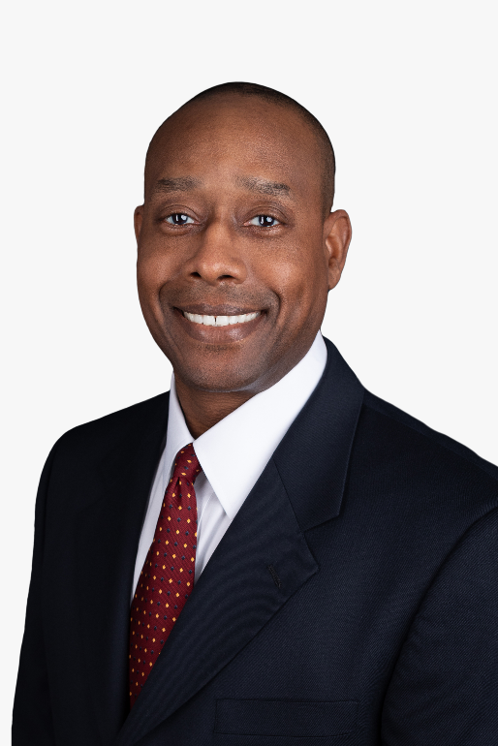
Ron Johnson, Branch Manager, Har-Ber Meadows

SPRINGDALE, Ark. – United Federal Credit Union (United) has appointed Ron Johnson the position of Branch Manager at its branch at Har-Ber Meadows branch at 6706 W. Sunset Ave. in Springdale, Arkansas.

As Branch Manager, Johnson will be responsible for maintaining the performance of the branch, and providing leadership and supervision to staff.

Johnson brings more than 27 years of banking and sales experience to his new role. Prior to joining United, Johnson spent eight years as a branch manager at a bank in northwest Arkansas.

He studied at University of Arkansas at Fort Smith and Arkansas Tech University. Johnson lives the credit union philosophy of ‘people helping people, not only through member service, but also community involvement. He is a board member and Chief Executive Officer of L.I.F.E. Prep, a board member for Economic Opportunity Agency, and is on the Advisory Board of Credit Counseling of Arkansas.

____________
About United
United Federal Credit Union has served its Members since 1949 by helping them to build a sound financial future. United consists of more than 186,000 Member/owners worldwide and manages assets in excess of $3.8 billion. Its corporate office and main branch are in St. Joseph, Mich., with additional branches in Arkansas, Indiana, Michigan, Nevada, North Carolina, and Ohio. Federally insured by NCUA. Equal opportunity lender. Equal housing lender. For more information visit UnitedFCU.com

# # #

