

**United Federal Credit Union – Press Release**

April 12, 2023

Contact: Diana Wake

Phone: (888) 982-1400 ext. 6891

Email: [dwake@UnitedFCU.com](mailto:dwake@UnitedFCU.com)

United Federal Credit Union, 150 Hilltop Road, St. Joseph, Michigan, 49085

**United Federal Credit Union Focuses on Financial Literacy in Local Communities**

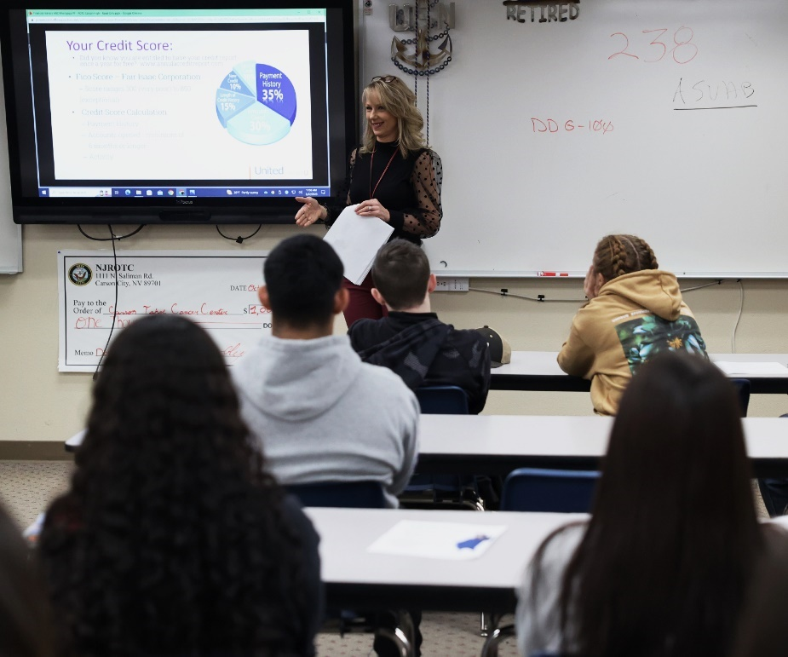

*Team United presents financial literacy course in Carson City, Nevada*

**ST. JOSEPH, Mich. –** The basics of finances. Do you remember when you learned them? For the communities where United Federal Credit Union (United) is located, some of the information comes directly from Team United.

Most people know they can go to their credit union to open a checking account, apply for a loan, or get a mortgage. But what they may not realize is those same employees you see when you stop by your branch, are also out in the community helping to teach financial wellness. Whether it is teaching a first-grade class in Indiana the difference between coins and cash, helping high school students in Ohio launch a small business, or going over credit and how it works with an adult education center in Arkansas, Team United lends their financial expertise to teach everyone the fundamentals.

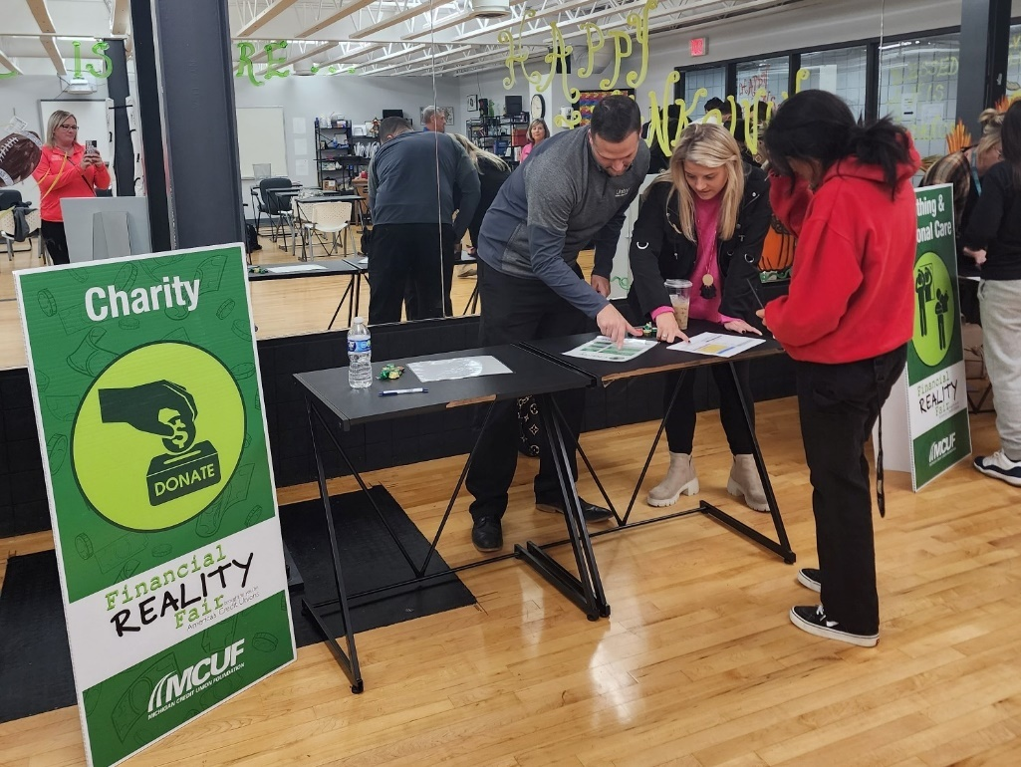

*Team United participates in financial wellness course at International Soccer Academy of America in Mishawaka, Indiana*

“United Federal Credit Union believes in the importance of supporting the community not just through donations and volunteering, but by teaching financial literacy to make sure everyone has access to the information that will help them make the best decisions when it comes to their money,” said Jacob Alexander, Branch Manager, Mishawaka, Indiana. “We have been fortunate to work with Junior Achievement in many regions to help spread financial literacy in schools, and we’ve already created partnerships with organizations and schools in our communities to teach financial education.”

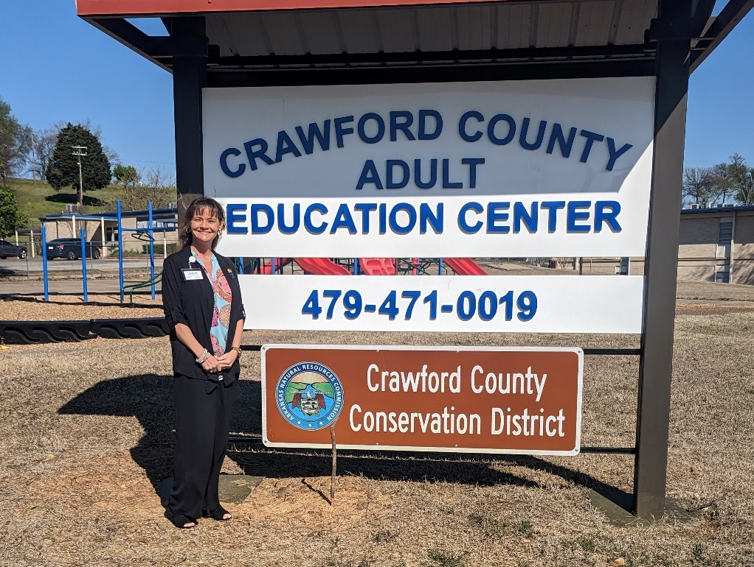

*Team United works with adults in Arkansas to teach financial courses*

When it comes to time in the classroom, topics range from the differences between a credit union and a bank, to how to budget and save, to the importance of building credit and maintaining a good score, and more.

“I love to see the spark go off when they learn from the lesson, the excitement they share when they participate and share their ideas and examples from their perspective,” said Brook Sweeting, Senior Relationship Development Manager in Reno, Nevada.

Teaching concepts around checking and savings accounts, or determining the difference between needs and wants, isn’t just a one-time lesson. In many communities, Team United stops by multiple times throughout the year to engage with students.

At United, our goal for the community is simple: to enhance the lives of our friends and neighbors. Assisting in our communities is just one way we live out the credit union philosophy of “people helping people”.

“We recently worked with one of our community partner schools to go over achieving financial wellness,” said Jay Barber, Branch Manager, Benton Harbor, Michigan. “Not only were we able to help educate them on the products and services we offer, but some of our Members shared their stories with us, including one woman who we’ve helped her with all of her major life events, from buying a car to buying a home. Helping our Members isn’t something we do once or twice a year with classes like these. Achieving their financial goals is something we do every single day for our Members.”

**____________**

**About United**

United Federal Credit Union has served its Members since 1949 by helping them to build a sound financial future. United consists of more than 186,000 Member/owners worldwide and manages assets in excess of $3.8 billion. Its corporate office and main branch are in St. Joseph, Mich., with additional branches in Arkansas, Indiana, Michigan, Nevada, North Carolina, and Ohio. Federally insured by NCUA. Equal opportunity lender. Equal housing lender. For more information visit [UnitedFCU.com](http://www.unitedfcu.com)

# # #