

**United Federal Credit Union – Press Release**

April 3, 2023

Contact: Diana Wake

Phone: (888) 982-1400 ext. 6891

Email: [dwake@UnitedFCU.com](mailto:dwake@UnitedFCU.com)

United Federal Credit Union, 150 Hilltop Road, St. Joseph, Michigan, 49085

**United Federal Credit Union Supports Marion City Schools Students to Launch Start-Up Coffee Shop**

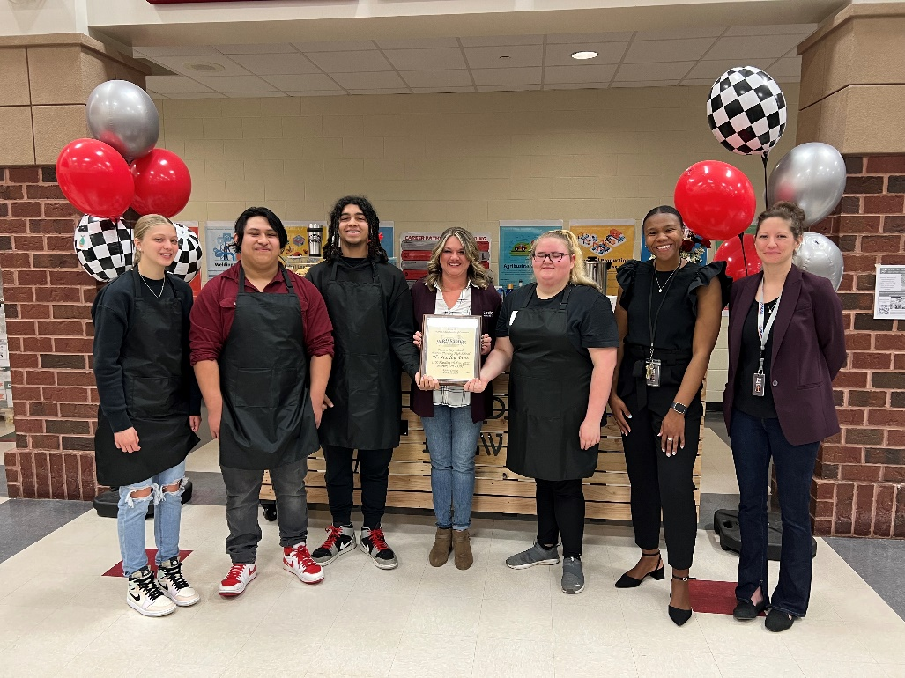

*Celebrating the grand opening of The Harding Brew*

**MARION, Ohio. –** There’s a new place in town to grab a cup of coffee in the morning: Harding High School. With the support of United Federal Credit Union (United), students in Olivia Davis’ Marketing Applications class have opened The Harding Brew. The coffee shop’s official ribbon cutting happened on March 31, 2023. In addition to the class running the shop, students and staff from the high school, the Marion Chamber of Commerce and United were in attendance for the event.

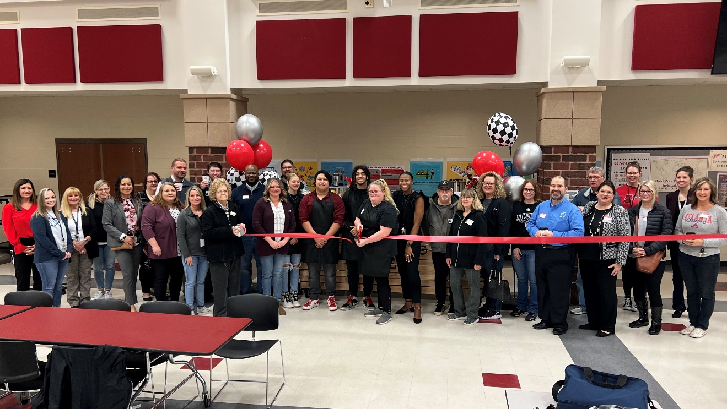

*Official ribbon cutting at The Harding Brew on March 31, 2023*

The new business was months in the making. It started in September as a simple lesson in class focusing on the coffee industry. Students were asked to do research on top coffee producing countries, trends within the industry, as well as the top national coffee chains and franchises. From there, they were required to gather and write a lean business plan for a hypothetical local, start-up coffee shop. But the lesson went a step further than Ms. Davis’ original plan.

“The students began talking about the possibility and convenience of having a coffee shop here at the school,” said Davis. “We did a little research and dug around only to find there had once been a coffee shop at Harding High School and the equipment was being stored away in a closet unused.”

The high schoolers took that idea and ran with it. After a few months of working on the project, they connected with United employees as they worked out how to make their vision of opening a business a reality.

“It was exciting to have the opportunity to work with this class from almost day one of the project,” said Leiha Lamb, Business Loan Officer with United. “During the last seven months, we have met regularly with the students and helped them solidify their business plan, offered advice on how to create effective marketing for a business, and offered general support. We worked with them as business mentors and helped them understand the business aspect of budgeting, record keeping, and pricing planning.”

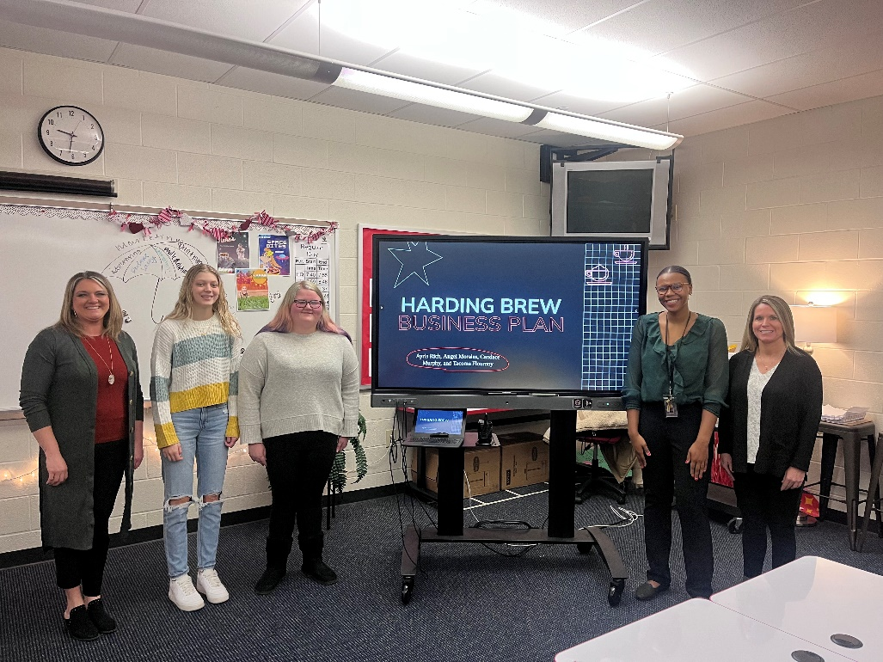

*The class worked with Team United to develop a business plan*

In addition to offering behind the scenes support, United gave the students seed money needed to help open the shop.

“It was really neat getting to see my students show up to our meetings with Amy and Leiha as entrepreneurs as opposed to marketing students,” said Davis. “They were full of ideas and questions, and most days took the lead on our meetings.”

After months of planning and fine tuning all aspects of the business, The Harding Brew opened to a soft launch in early March 2023. Students and staff are able to stop by the shop on Wednesdays and Fridays before schools starts, during homeroom, and first and second period.

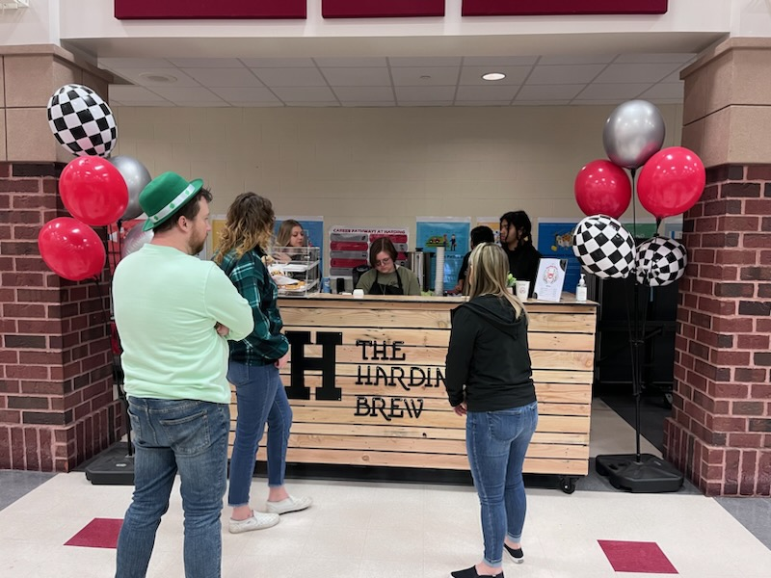

*Students and staff grab coffee during the shop’s soft opening*

“Throughout this process, I’ve realized anything is possible,” said Ayris Rich, Senior. “At first, I did not think this coffee shop was going to be successful and actually happen. I didn’t think students would want coffee at school and would rather go somewhere else. But it turns out the students are excited to have a coffee shop here at school.”

For now, the menu is small and includes hot coffee (regular and French Vanilla), donuts, and muffins on Fridays. Just like the big national coffee chains, customers can order at the shop or online. The students say the next step is to expand the menu to include iced coffee and hot chocolate.

“Now that the shop is open, I’m excited to see how it will grow and change for the better,” said Tacoma Jermain Flournoy Jr., Junior. “I hope it will become even more well known in the school, and we’ll be able to expand and have a whole room dedicated to the coffee shop. Something that’s just ours.”

For the students in Ms. Davis’ class, the experience of learning to start and then run their own business will help them well past this school year.

“I am getting the chance to have real job experience while I’m at school,” said Candace Murphy, Sophomore. “This project has helped prepare me for my future since I want to go to college and study business.”

For the team at United, this is just one way they are able to give back to the community and help make it a great place to live.

“Getting to work closely with community partners like United gave these students a first-hand look at the jobs and careers local to them,” explained Davis. “Being able to see my students engage and explore their ideas for building this business with United was my favorite part of this experience. Seeing my students apply learned skills to a real-life venture like Harding Brew is not only rewarding, but demonstrates how impactful career technical education can be.”

“These students are our future leaders here in the community and I am so glad United had the chance to be a part of this journey to help these students and the Marion City Schools,” Amy Marshall said proudly.

**____________**

**About United**

United Federal Credit Union has served its Members since 1949 by helping them to build a sound financial future. United consists of more than 186,000 Member/owners worldwide and manages assets in excess of $3.8 billion. Its corporate office and main branch are in St. Joseph, Mich., with additional branches in Arkansas, Indiana, Michigan, Nevada, North Carolina, and Ohio. Federally insured by NCUA. Equal opportunity lender. Equal housing lender. For more information visit [UnitedFCU.com](http://www.unitedfcu.com)

# # #