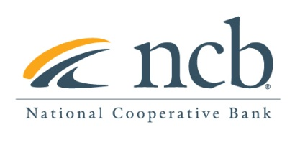

**NEWS RELEASE**

**Contact:**

Mary Alex Blanton – NCB (703) 302-8876  
[mblanton@ncb.coop](mailto:mblanton@ncb.coop)

**National Cooperative Bank Releases 2022 Mission Report Highlighting Initiatives Serving Low-and-Moderate-Income Communities and New Cooperative Development**

Arlington, Va (April 20, 2023) — National Cooperative Bank (NCB), a leading financial services company dedicated to providing banking products to cooperatives and socially responsible organizations nationwide, committed $475 million of its overall annual production to initiatives serving low-and moderate-income communities and new cooperative development during 2022.

NCB’s mission is to support and be an advocate for America’s cooperatives and their members, especially in low-income communities, by providing innovative financial and related services. The capital was provided through direct lending and investments in the following impact sectors:

* **Housing:** $175.7 million for affordable housing initiatives and low-and-moderate- income mortgage loans nationwide.
* **Non-profit & Community Development:** $43.4 million to finance commercial real estate in low-income areas and organizations focused on economic development.
* **Credit Unions:** $80.7 million to low-income or community development credit unions.
* **Food:** $8 million to expand access to healthy food in low-and moderate-income communities.
* **Hardware:** $8.2 million to support hardware retailers nationwide.
* **Health Care:** $53.9 million to support healthcare and aging services.
* **Renewable Energy:** $89.7 million to finance solar panel installation in low-and moderate-income communities.
* **Small Business:** $425,000 to support small businesses and farm loans.

In addition, NCB provided $12 million in facilitated transactions and $2.9 million to support entities serving low-income communities and co-op development.

Please read our full mission report: [NCB 2022 Mission Report](https://impact.ncb.coop/hubfs/assets/resources/2022-NCB-Mission-Report.pdf)