PRESS RELEASE FOR IMMEDIATE RELEASE: April 6, 2023

MEDIA CONTACT:
Carla Keister
Senior Marketing Communications Writer
Tower Federal Credit Union

301-497-7000, ext. 7144
carla.keister@towerfcu.org

Tower Federal Credit Union Celebrates 70 Years with a $70,000 Donation to Local Charities through the TowerCares Foundation

To celebrate Tower Federal Credit Union’s 70th anniversary, the TowerCares Foundation donated $70,000 to local charities supporting military heroes, Veterans and children in need. The donation coincided with Tower’s refreshed brand, logo, and website.

[April 6, 2023 – Laurel, MD] Founded in 1953, Tower Federal Credit Union recently celebrated its 70th anniversary with a special $70,000 donation to charities through the TowerCares Foundation, the credit union’s philanthropic arm. Seven TowerCares grantees each received $10,000 donations.
“The TowerCares mission is to help children in need as well as brave individuals and their families who have sacrificed while defending our country,” said Rick Stafford, Tower’s President & CEO and President of the TowerCares Foundation. “In honor of Tower’s 70-year legacy of supporting the defense community, we wanted to make a special donation to local charities who align with the TowerCares mission.”
What made the donation even more special, Stafford said, is that Tower employees voted for and selected the charities to receive the $10,000 donations. “Tower employees have been ardent supporters of the TowerCares Foundation from the start,” he said. “They are the heart and soul of Tower. It only seemed fitting that we let them have the opportunity to select the charities for this special donation as part of our new brand launch.”
“We are so grateful for the continuously-increasing support from Tower and TowerCares over the past four years,” said Lesli Creedon, President & CEO of Make-A-Wish® Mid-Atlantic, one of the seven charities to receive the special $10,000 donation. “The TowerCares Foundation and the entire Tower team understands the life-changing impact of a wish for a child with a critical illness. A wish can be the spark that helps these children believe that anything is possible and gives them strength to fight harder against their illnesses. Tower’s generous gift will give hope and joy to both children of military families and kids throughout D.C., Maryland and Northern Virginia.”
The following seven local charities received a $10,000 donation from TowerCares:
Boys & Girls Club of Annapolis & Anne Arundel County – Located in Annapolis, Md., the Boys & Girls Club of Annapolis & Anne Arundel County provides before- and after-school programs for students in safe, nurturing environment with a focus on community service, outreach, academic success, and career preparation.
Casey Cares – Casey Cares, located in Columbia, Md., provides ongoing, uplifting palliative support to children diagnosed with critical illness, and their families, in Maryland, Washington, D.C. and Virginia.
Comfort Cases – Located in Rockville, Md., Comfort Cases provides overnight bags for youth entering the foster care system in Maryland, Washington, D.C. and Virginia. The charity helps to provide basic needs, comfort, and a sense of dignity by giving these children a special bag they can call their own.
Gigi’s Playhouse – Gigi’s Playhouse, located in Annapolis Md., seeks to change the way the world views Down syndrome through national campaigns and educational programs, and by empowering individuals with Down syndrome, their families and community.
Hero Dogs – Located in Brookeville, Md., Hero Dogs trains and provides service companion and therapy animals for disabled Veterans and first responders in the Washington, D.C. metropolitan area.

Make-A-Wish® Mid-Atlantic – Make-A-Wish® Mid-Atlantic, located in Bethesda, Md. creates life-changing wishes for children with critical illnesses through its Uniformed Services Family Wish Fund, which helps children whose parent(s) are active duty, reserve or Veterans.

Maryland Center for Veteran Education & Training (MCVET) – Located in Baltimore, Md., MCVET empowers homeless Veterans to achieve economic self-sufficiency and residential stability.

The $70,000 donation also coincided with Tower’s new, refreshed brand, logo and website, Stafford said. The refreshed branding is part of a larger growth strategy, to honor Tower’s 70-year legacy in the defense community while looking ahead to the future, to provide an enhanced member experience, and engage with and appeal to a younger generation of members.
To learn more about the TowerCares Foundation, visit towercaresfoundation.org.

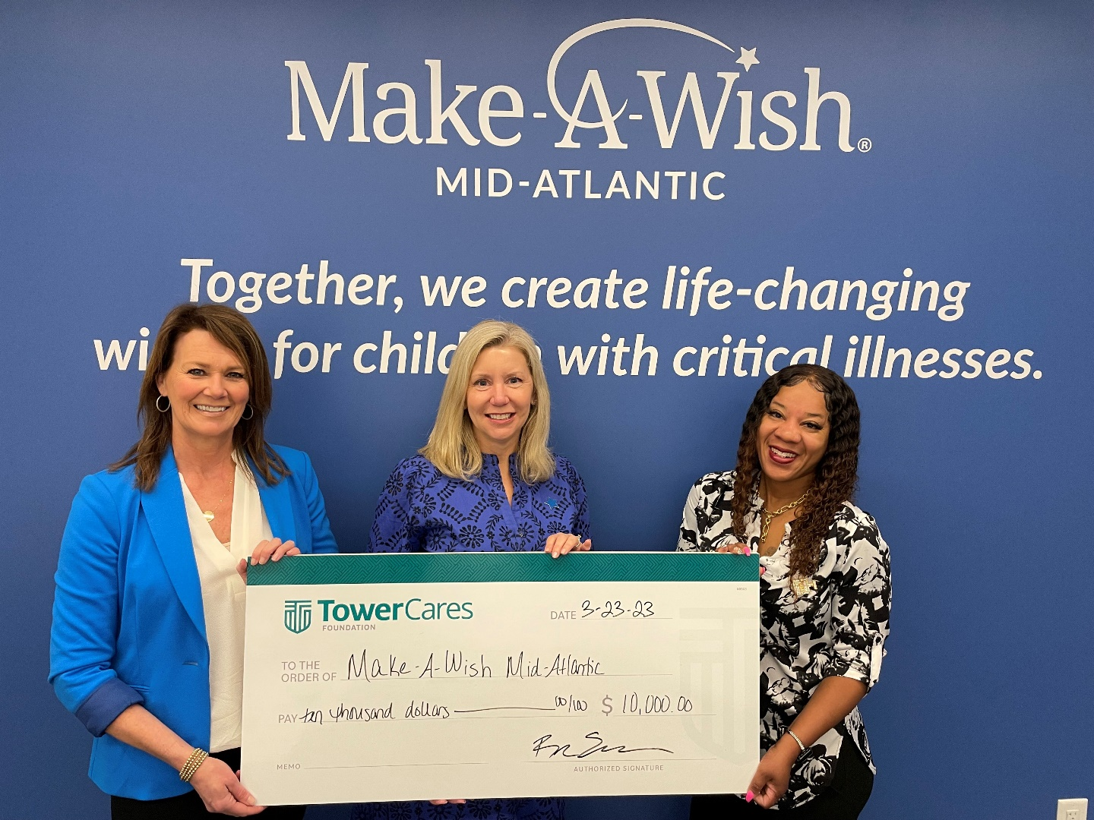
PHOTO CAPTION: Mary-Brigid McCauley (left) and Rochelle Hazzard (right), ambassadors from the TowerCares Foundation, the philanthropic arm of Tower Federal Credit Union, present a special $10,000 donation to Lesli Creedon, President & CEO of Make-A-Wish® Mid-Atlantic. The donation was part of a larger $70,000 donation to celebrate the credit union’s 70th anniversary. Seven local charities each received $10,000 to help support military heroes, Veterans and children in need.

###

About Tower Federal Credit Union
Tower Federal Credit Union is a member-owned, non-profit financial institution with headquarters in Laurel, MD. Established in 1953, Tower is the largest federal credit union in Maryland with over $4.2 billion in assets. It provides a full array of financial products and services and serves more than 220,000 members worldwide. Tower serves its local-area members with 12 branches in Anne Arundel, Baltimore, Howard, and Prince George’s counties and four branches at Fort Meade, as well as online services and mobile banking at towerfcu.org.

