United Federal Credit Union – Press Release
April 17, 2023

Contact: Diana Wake
Phone: (888) 982-1400 ext. 6891
Email: dwake@UnitedFCU.com
United Federal Credit Union, 150 Hilltop Road, St. Joseph, Michigan, 49085

United Federal Credit Union Recognized for Community Commitment by United Way of Southwest Michigan
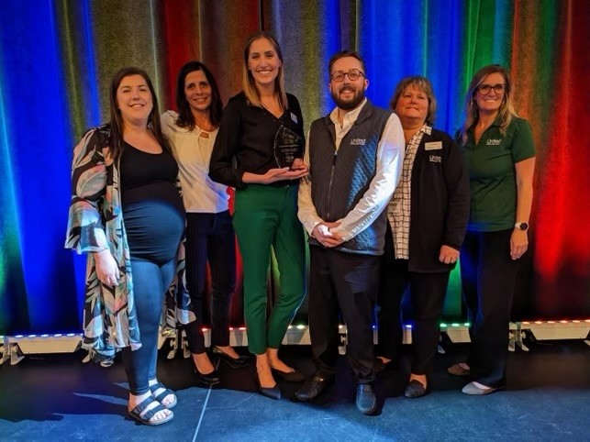
Team United receives 2022 Live United Award

ST. JOSEPH, Mich. – United Federal Credit Union (United) has received the 2022 Live United Award as part of the United Way of Southwest Michigan’s annual Celebration awards.

“United strives to live by the credit union philosophy of people helping people. Our culture promotes service, community enhancement and volunteerism,” said Jodie Kitchell, Regional Vice President. “We are proud to support the United Way of Southwest Michigan and to have received this award in recognition of our community efforts.”

The Live United Award recognizes an organization or individual who embodies the mission, vision and goals of United Way and lives out the idiom of Give, Advocate & Volunteer. According to the United Way, “the winner will demonstrate how we can and should fight for the health, education, and financial stability of every person in every community.”

“By extensively leading, sponsoring, encouraging, and supporting volunteering among their employees, United Federal Credit Union not only lives out the LIVE UNITED philosophy but also the credit union philosophy of people helping people,” said Anna Murphy, President and CEO of United Way of Southwest Michigan. “We are proud to say that United Federal Credit Union is one of our LIVE UNITED award winners this year.”

United participates annually in many United Way initiatives. Employees pledge funds during its annual workplace campaign, and also rolls up their sleeves by volunteering for United Way’s Rake A Difference and Pop Up Giving events.

United most recently won the Inspired Giving Award and Employee Chair of the Year – Large Business Award. The Inspired Giving Award recognizes a company for exception al results in a new or reestablished employee campaign. The Employee Chair of the Year Award recognizes someone who has shown exemplary commitment to the United Way in the area of Give, Advocate, and Volunteer.

____________
About United
United Federal Credit Union has served its Members since 1949 by helping them to build a sound financial future. United consists of more than 186,000 Member/owners worldwide and manages assets in excess of $3.8 billion. Its corporate office and main branch are in St. Joseph, Mich., with additional branches in Arkansas, Indiana, Michigan, Nevada, North Carolina, and Ohio. Federally insured by NCUA. Equal opportunity lender. Equal housing lender. For more information visit UnitedFCU.com

# # #

