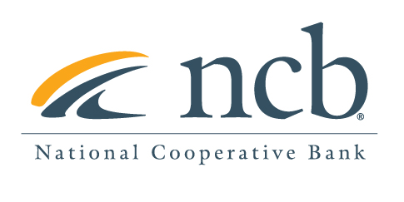

# 

# NEWS RELEASE

# Contact: Mary Alex Blanton, NCB (703) 302-8876

**National Cooperative Bank Announces 2023 Board of Directors and Board Leadership**

Arlington, VA (May 15, 2023)— National Cooperative Bank (NCB), a leading financial services company dedicated to providing banking products and services to cooperatives, their members, and socially responsible organizations nationwide, is pleased to welcome one new member to its Board of Directors.

The Board welcomes Maria Smedley, Esq, Vice President of Human Resources at Performance Foodservice located in Little Rock, Arkansas.

NCB thanks Christine Neal and Debra Huddleston whose terms as Board members has ended and Andrea Levere, NCB’s presidential appointee who is retiring after 10 years on the NCB Board.

Jennifer Dolin, Principal, Jen Dolin Consulting will be NCB’s new board chair and Marc Friedman, CFO of a Few Cool Hardware Stores will assume the vice-chair position.

The Board benefits from a diverse group of members, who come from a variety of industries in which cooperatives play an important role. In addition to Ms. Smedley, the NCB Board Members are:  

* Jennifer Dolin (Chair), Principal, Jen Dolin Consulting, San Francisco, CA;
* Marc Friedman (Vice-Chair), CFO of a Few Cool Hardware Stores in Washington, DC;
* Josh Ablett, Chief Information Security Officer, Adelia Associates, New Bedford, MA;
* Caroline Blakely, President & CEO, Rebuilding Together, Washington, DC;
* Robyn DesHotel, Chief Financial Officer, National Co-op Grocers, St. Paul, MN;
* Thomas Fink, Capital Markets Executive, New York, NY;
* Janis Herschkowitz, past President and CEO of PRL, Inc. in Cornwall, PA.;
* Gigi Hyland, Executive Director, National Credit Union Foundations, Washington, D.C.;
* Patrick Jury, Principal, Patrick S. Jury Advisor, LLC, Des Moines, IA;
* Brian Obergfell, Chairman, and Partner, Emmet, Marvin & Martin, LLP, New York, NY;
* Andrew Reicher, Former Executive Director, UHAB, New York, NY;
* Elizabeth Vealey, President, Sophius, LLC, Lancaster, NY; and
* Curtis Wynn, CEO, SECO Energy, Sumterville, FL

About National Cooperative Bank: National Cooperative Bank is dedicated to strengthening communities nationwide through the delivery of banking and financial services, complemented by a special focus on cooperative expansion and economic development. NCB provides financial products and services for the nation’s cooperatives, their members, and socially responsible organizations. Headquartered in Washington, DC, the Bank has offices in Alaska, New York, Ohio and Virginia. To learn more, visit [www.ncb.coop,](https://app.meltwater.com/icm-web/outreach/compose/www.ncb.coop,) National Cooperative Bank on Facebook and Instagram, or on Twitter @natlcoopbank.