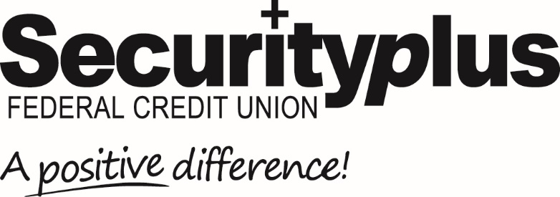

For Release: Immediate Contact: Lisa Allender
410-281-6248
lisa.allender@securityplusfcu.org

Securityplus Federal Credit Union
Receives Diamond Award for Financial Education Marketing

Baltimore, MD (May 18, 2023) Securityplus Federal Credit Union, headquartered in Baltimore, Maryland was recognized by the Credit Union National Association (CUNA) Marketing and Business Council with a Diamond Award.
Securityplus won in the Financial Education category for its “Know Money, Know Empowerment” financial education initiative to reach underserved individuals residing in Baltimore City, aiming to increase financial literacy, develop money management skills, and promote long term financial security and success.
The most prestigious annual credit union marketing competition, the Diamond Awards recognize and reward creative excellence and outstanding results in 35 categories, with this year’s competition including 1,246 entries.
"It is with immense pride and gratitude that we accept the distinguished Credit Union National Association Diamond Award for our trailblazing 'No Money, No Empowerment' program," said Brian Holloway, Chief Marketing Officer at Securityplus Federal Credit Union. "This prestigious accolade not only highlights our unwavering dedication to financial literacy and empowerment but also serves as a beacon of inspiration for our passionate team who work relentlessly to bring this innovative solution to our valued members and the communities we serve. The 'No Money, No Empowerment' program has already transformed countless lives, sparking a ripple effect of financial well-being and resilience. As we celebrate this remarkable achievement, we remain steadfast in our mission to create a brighter financial future for our members and look forward to breaking new ground in the world of credit unions."
Securityplus Federal Credit Union is a $560⁺ million not-for-profit, member-owned financial institution serving the Greater Baltimore Area and beyond. Founded in 1938, Securityplus is one of Maryland’s largest full-service credit unions, with over 34,000 members. With a focus on making a positive difference, Securityplus is a leader in digital banking, offering 24/7 access to inclusive, easy-to-use banking products and services for consumers, families, businesses, and non-profits. For more information, visit securityplusfcu.org

# # # #

