FOR IMMEDIATE RELEASE

CONTACT:
Jesse Kohl, President
InterLutions, LLC
(414) 427-3637

Revolutionizing Employee Benefits: CUSO Reveals Success Stories from Leading Credit Unions

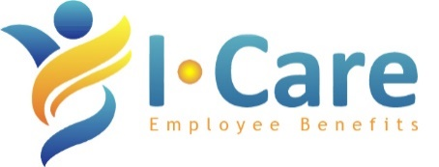
MILWAUKEE, WI – June 13, 2023 – InterLutions, an innovative employee benefits CUSO, recently hosted a forum exclusively for large credit unions to share their “results of collaboration.” The CUSO was formed to help lower medical insurance costs, mitigate the risk of high-cost claims, and enhance employee benefit plans.

“We recognize the crucial role that employee benefits play in attracting and retaining top talent,” said Jesse Kohl, President of InterLutions. “We also know that employees are the most important assets of the credit union movement, and that they deserve better. It’s time for credit unions to explore a new path to change the trajectory of rising medical insurance costs.”

The forum, held on June 6, was titled, “Results of Collaboration: How Large Credit Unions Are Enhancing Employee Benefits and Lowering Costs” and shared case studies highlighting how three credit unions leveraged data, technology, and collaboration to deliver rich and competitive benefits to their employees. Highlights from the forum included:

- Case Study # 1: A credit union with 400 employees was facing year-over-year double-digit premium increases. By leveraging I-Care’s enhanced claims data, they lowered their pharmacy utilization expenses by over $430,000 with minimal provider and employee disruption.
- Case Study #2: A credit union with 1,000 employees had outgrown their insurance broker and looked to I-Care to put them on a long-term strategic path focused on employee growth, HR technology, network optimization, and claims analytics. The new strategic path saved the credit union over $900,000 in year one.
- Case Study #3: A credit union with 200 employees was experiencing rising high-cost claims activity and looked to I-Care’s collaborative insurance captive to mitigate their claims risk through proactive health management tools and cost containment measures. Lowering their healthcare claims costs allowed the credit union to reinvest in the well-being of their employees and improve overall productivity.

Interested credit unions can receive a copy of the forum’s slide deck or request a free copy of the CUSO’s “C-Suite Guide to Enhancing Benefits and Lowering Costs” white paper by contacting InterLutions at (414) 433-0174. Credit unions can also hear success stories directly from the CUSO’s clients by viewing testimonial videos at InterLutionsCUSO.com.

About InterLutions, LLC
InterLutions is a credit union service organization (CUSO) focused on providing innovative business solutions to advance the credit union movement. At its core, InterLutions believes in the idea that collaboration within the credit union industry will provide more reliable and cost-efficient ways to keep credit unions strong and healthy. Please visit InterLutionsCUSO.com to learn more and follow us on LinkedIn.

