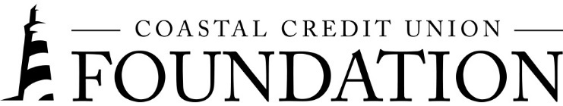
NEWS RELEASE
Contact: Joe Mecca
VP, Communication / Spokesperson
919-420-8044 / jmecca@coastal24.com
Final – For Immediate Release

Coastal Credit Union Foundation Awards Grants to Three Local Nonprofits
RALEIGH, N.C. (June 23, 2023) – The Coastal Credit Union Foundation announced today that it has awarded $170,000 to three nonprofits in North Carolina.

The Foundation’s most recent grantees include:
- Catholic Charities of the Dioceses of Raleigh $30K
- The Women's Center of Wake County $40K
- Band Together and United Way: Mighty Giveback $100K

“The three grants given to these nonprofits will directly assist individuals facing affordable housing challenges in our communities,” said Emily Nail, Executive Director of the Coastal Foundation. “Affordable housing is a growing issue and it’s one of the key areas that our Foundation is focused on. We are happy to provide grants to these nonprofits to support their continued efforts to improve our local communities.”

The Coastal Credit Union Foundation focuses on funding projects in four key areas: promoting financial well-being, increasing affordable housing, supporting financial education, and improving access to resources. Year to date, the Foundation has contributed $320,000 to 13 community organizations.

About the Coastal Credit Union Foundation
The Coastal Credit Union Foundation is a separate entity from the credit union. The mission of the Foundation is to enrich the lives of our members and their communities by providing financial support to 501(c)(3) organizations, particularly in the 16-county market of central North Carolina.
###

.

