FOR IMMEDIATE RELEASE

CONTACT:
Kevin Chiappetta, CFA, President
QuantyPhi, LLC
(414) 433-0176

Kevin Chiappetta Elected Presidents Council Representative from the Midwestern US Subregion for the CFA Institute

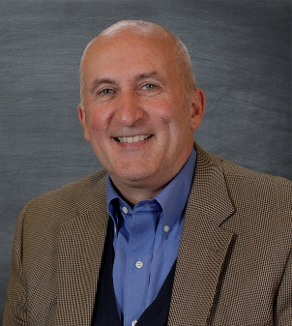
MILWAUKEE, WI – June 2, 2023 – QuantyPhi is delighted to announce the election of Kevin Chiappetta, CFA, President of QuantyPhi, as the Presidents Council Representative (PCR) from the Midwestern US Subregion for the esteemed CFA Institute.

The CFA Institute is a global association of investment professionals that sets the standard for excellence in the financial industry. The Presidents Council, composed of representatives from various subregions, plays a crucial role in shaping the Institute's policies, promoting ethical practices, and fostering professional development within the industry.
Kevin Chiappetta, CFA, President of QuantyPhi.

Chiappetta, a highly accomplished professional with a wealth of experience in the finance sector, emerged victorious in a regional election process. His extensive knowledge, leadership skills, and dedication to promoting the highest standards of ethics and professionalism made him an ideal candidate for this prestigious role.

As the PCR from the Midwestern US Subregion, Chiappetta will serve as a strong voice for the region, advocating for the interests of investment professionals and ensuring that their concerns are represented at the highest level. He will collaborate closely with other council members to contribute to the development of industry-leading standards, policies, and initiatives that drive the advancement of the finance profession.

“I am grateful for the trust placed in me by my peers and I vow to work diligently to uphold the CFA Institute's mission of fostering a more transparent, fair, and trustworthy financial industry,” Chiappetta said. “I am determined to leverage my expertise and influence to advocate for the interests of professionals and investors in the Midwestern US Subregion.”

Chiappetta’s education includes a bachelor's degree in Accounting from St. Norbert College in De Pere, WI. He is a Chartered Financial Analyst (CFA) charter holder and an active member and volunteer for the CFA Institute in Charlottesville, VA. He was elected to the CFA Society Milwaukee Board in July 2019 and elected as President in 2021. He has been an active member of the society for 25+ years.

About QuantyPhi, LLC
QuantyPhi, LLC is a wholly owned credit union service organization. The CUSO specializes in credit union balance sheet optimization. QuantyPhi’s mission is to build better credit unions by building balance sheets with muscle, flexibility, and resilience. Please visit QuantyPhi.com to learn more and follow us on LinkedIn.

