

United Federal Credit Union – Press Release
June 9, 2023

Contact: Diana Wake
Phone: (888) 982-1400 ext. 6891
Email: dwake@UnitedFCU.com
United Federal Credit Union, 150 Hilltop Road, St. Joseph, Michigan, 49085

United Federal Credit Union Mortgage Advisor Named in Top 250 Latino Mortgage Originators Award
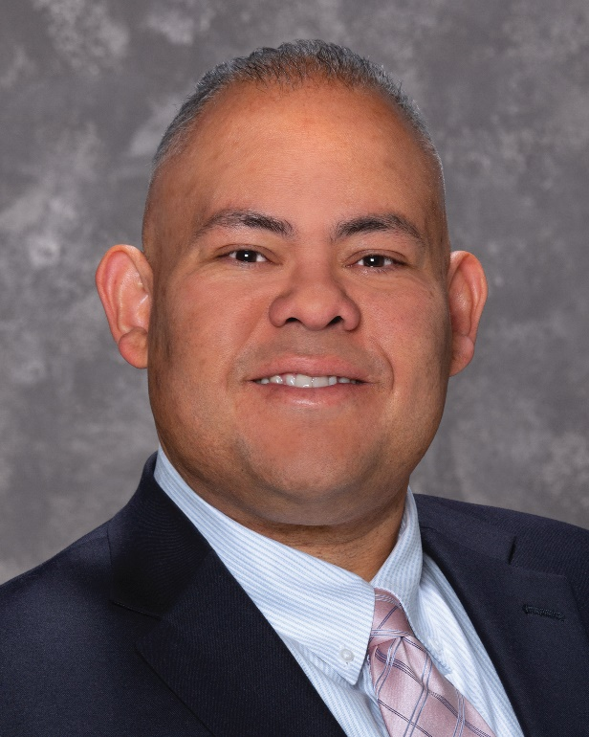
Roberto Castillo, Mortgage Advisor, Sparks, Nevada

SPARKS, Nevada – United Federal Credit Union Mortgage Advisor, Roberto Castillo, was recently named to the “Top 250 Latino Mortgage Originators” list by the National Association of Hispanic Real Estate Professionals (NAHREP).

Castillo has been with United since 2017. In his role, he is responsible for driving mortgage loan growth in the Reno-Sparks area. Castillo grew up in Sparks and brings his extensive knowledge of the local area into every interaction with United Members.
“It takes a high degree of effort, ability and compassion from everyone at United to help our Members find the home of their dreams,” said Castillo. “Every year I set out to be a high contributing part of the Northern Nevada community, and I feel proud of all the opportunities that our team has to help so may people. I would not be able to help our community without the people standing beside me.”

More than 1,100 agents were nominated across the United States and Puerto Rico. The rules for the award state “nominees are required to submit their individual number of closed residential transactions to be ranked against other nominees”.

According to NAHREP, the awards highlight the candidates’ “work every day in their local market to make homeownership a reality for families … The Top 250 list recognizes agents whose hard work and dedication has led them to close an outstanding number of transactions in an effort to increase the rate of sustainable Hispanic homeownership”.

“This award is a true testament to the commitment Roberto has to United and the Members he supports,” said Mike Randall, United Senior Production Manager. “Roberto’s work ethic and daily effort to reach his goals in support of his borrowers is unmatched. It is why he is so successful as a mortgage originator in our industry. We are all proud of Roberto and this outstanding accomplishment he has achieved.”

____________
About United
United Federal Credit Union has served its Members since 1949 by helping them to build a sound financial future. United consists of more than 186,000 Member/owners worldwide and manages assets in excess of $3.8 billion. Its corporate office and main branch are in St. Joseph, Mich., with additional branches in Arkansas, Indiana, Michigan, Nevada, North Carolina, and Ohio. Federally insured by NCUA. Equal opportunity lender. Equal housing lender. For more information visit UnitedFCU.com

# # #

