FOR IMMEDIATE RELEASE

CONTACT:
Jesse Kohl, President
InterLutions, LLC
(414) 427-3637

A CUSO and an Association Collaborate to Deliver Competitive Health Plans to Business Members

MILWAUKEE, WI – July 25, 2023 – InterLutions recently launched a partnership with the Healthcare Credit Union Association (HCUA) to help credit unions deliver competitive health plans to their members, business accounts, and employees. The collaboration will give more consumers access to I-Care, a pioneering employee benefits solution designed to mitigate rising health costs.

“As a trusted association of credit unions that serve the healthcare industry, we truly understand the challenges our members face, so we are excited to deliver a competitive benefits solution that can change the course of ever rising medical insurance costs,” said Benita Harp, Executive Director of HCUA. “We believe InterLutions’ innovative offerings, leadership, and exceptional service levels align well with HCUA’s mission and we expect this alliance to bring best-in-class value to the members and business accounts of our association.”

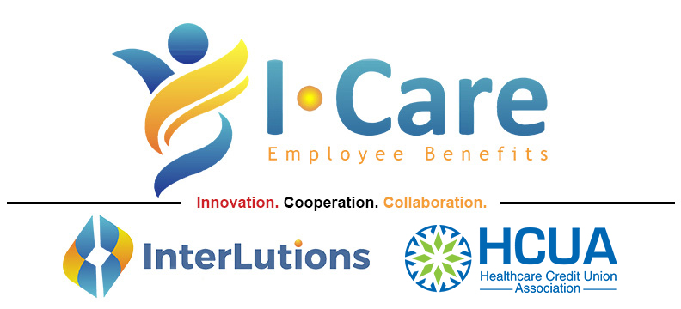

InterLutions’ collaborative benefits plan, branded as the I-Care Health Plan, allows credit unions to market and refer the CUSO’s health plans to their members and business accounts. The program was built to provide small employers and independent contractors with a competitive alternative to the Insurance Exchange through enhanced underwriting, pooled employee programs, and flexible plan designs.

Jesse Kohl, President of InterLutions said, “Similar to HCUA, our CUSO was formed by listening to credit unions in an effort to understand their primary business challenges. I-Care was designed by credit unions and has a proven track record of success. Our clients are experiencing healthcare cost efficiencies they could not achieve previously on their own.”

According to InterLutions, since its inception in 2015, I-Care has delivered benefit solutions to over 10,000 members and offers HR departments support services via forums, conferences, workshops, and one-on-one consulting. InterLutions also hosts in-person and digital HR networking forums where credit union representatives can share insights into common benefit-management challenges. Alliances with innovative associations across the country increases the ability to help credit unions and their members attract and retain the necessary talent to thrive.

About InterLutions
InterLutions is a credit union service organization (CUSO) focused on providing innovative business solutions to advance the credit union movement. At its core, InterLutions believes in the idea that collaboration within the credit union industry will provide more reliable and cost-efficient ways to keep credit unions strong and healthy. Please visit InterLutionsCUSO.com to learn more and follow us on LinkedIn.

About Healthcare Credit Union Association
In 2007, several passionate CEOs of healthcare credit unions met with the idea of supporting each other through collaborative efforts. Today HCUA is a professional association of 50 credit unions that serve healthcare employees and their families throughout the United States.

