**NEWS RELEASE**

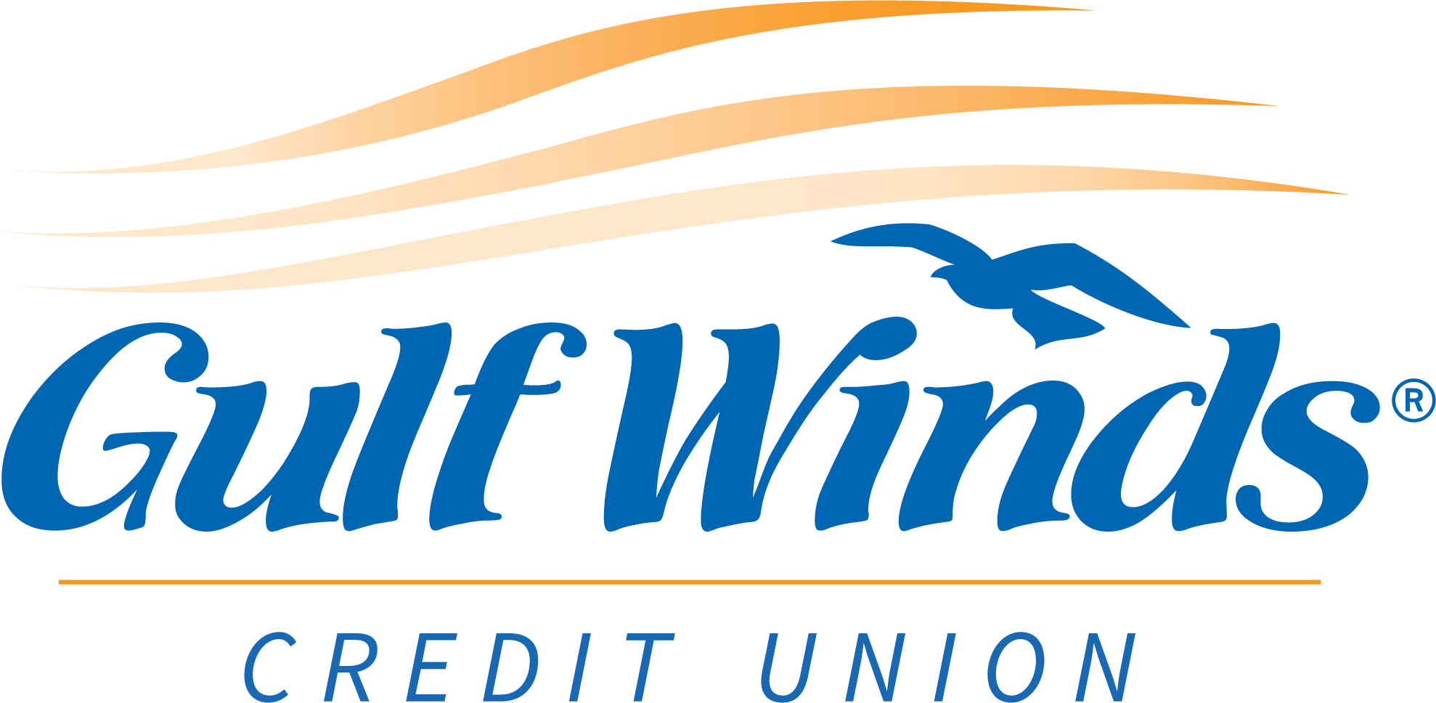

For Immediate Release

-------------------------------------------------------------------------

**Gulf Winds Credit Union**

For more information, contact:

**Lauren Clark, Public Relations Specialist**Office: 850-479-9601, x149 | Email: [Lauren.Clark@gogulfwinds.com](mailto:Lauren.Clark@gogulfwinds.com)   
-------------------------------------------------------------------------

**Gulf Winds Cares Foundation Donates to Alabama Nonprofits**

**Pensacola, Florida (July 7, 2023) —** The Gulf Winds Cares Foundation made several gifts in Alabama this month. A total of $10,250 was given to four local nonprofits in the pursuit of caring for those in need, a value held closely by Gulf Winds Credit Union.

Two of these gifts were for local chapters of the YMCA to support youth programs. YMCAs in small towns play an integral part in serving our communities. Children gain valuable skills and parents can continue to work.

The Gulf Winds Cares Foundation proudly donated $2,000 each to the Brewton and Monroeville Area YMCAs.

“Without Gulf Winds’ assistance, it would be a lot more difficult to serve our youth through providing summer camp, after school care, preschool, and our youth sports,” said Brewton Area YMCA CEO, Rob Kirkland. “Donations keep costs down and help those who would not qualify financially to be part of the program.” Ricky Powell, CEO of the Monroeville Area YMCA added, “Around 42 percent of our youth program participants utilize our services thanks to scholarships, funded in part by this donation.”

The Foundation also made a gift of $5,000 to the Escambia County Agency on Aging to support their senior centers and a gift of $1,250 to Single Parents Raising a Gift (SPRAG) to support single parents and their often challenging endeavors, as well as foster children and parents. “SPRAG is a small organization, but we can do big things thanks to Gulf Winds,” said Sue Lee, SPRAG advisory board member. Additionally, SPRAG supports Drexel and Honeybees, a donation-only restaurant in Brewton that the Gulf Winds Cares Foundation also supports.

“Gulf Winds loves being part of the communities that we serve. Knowing that our donations positively impact the lives of seniors in our communities is so rewarding,” said Vice President of Regional Sales, Lee Ann Allen. “Our support is critical to the work that the Agency on Aging does in Escambia County, Alabama, and we’re so proud to be able to be part of their success.“

The Gulf Winds Cares Foundation was founded in January 2021 to formalize the longstanding charitable efforts of Gulf Winds Credit Union. The Foundation’s mission is to create a sustainable funding source for community organizations that provide elder services, youth services, basic needs and financial education. Our giving philosophy is to provide annual donations that can be depended on year-after-year, to help funded partners create sustainable programmatic results.

XXX

**About Gulf Winds:**

Since 1954, Gulf Winds Credit Union has offered products and services that *Move Members Forward*. Gulf Winds provides 81,000+ members with the convenience of 13 branch locations, digital banking, nationwide surcharge-free ATMs and the support of more than 200 knowledgeable employees committed to providing excellent service. Membership is open to anyone that lives, works, worships or attends school in North Florida, Southern Alabama and Southern Georgia. Visit GoGulfWinds.com for more information.