****FOR IMMEDIATE RELEASE**

Southland Credit Union welcomes Elizabeth Egan as Vice President of Human Resources

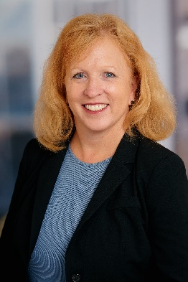*Los Alamitos, CA (July 10, 2022)* – Southland Credit Union, a Southern California Credit Union with more than 63,000 Members, is pleased to announce the appointment of Elizabeth Egan, SPHR, SHRM-SCP, as Vice President of Human Resources. In her role, Egan will lead the Human Resources department and will aid in guiding the career growth and development of Southland’s Associates.

Egan has34 years of experience in Human Resources and 20 years of management experience. Her most recent leadership roles include Head of HR for Toll Group, Global Vice President, Human Resources for Juvo Plus and Vice President, Human Resources for Behavioral Health Works, Inc.

“We are excited to welcome Liz to Southland Credit Union,” said Thomas Lent, President and CEO. “Her extensive experience with a variety of HR disciplines and her passion for coaching and mentoring make her an excellent fit for our team.”

Egan’s Human Resources experience spans several industries, from banking and finance to consumer products, manufacturing, retail, health care and others. In her previous role she provided HR consulting services to companies across Southern California, including Disney, Arbonne and Nuvision Credit Union.

“I’m very excited to join Southland Credit Union and have the opportunity to work with such a talented team of professionals,” said Egan.

The appointment follows the retirement of Barbara Bannister, who served Southland Credit Union for more than 10 years.

“On behalf of our Board of Directors and Executive Team, I would like to thank Barbara for her dedicated service to the credit union,” said Lent. “Guided by Barbara’s leadership and passion for workplace excellence, Southland was given multiple Workplace Excellence Awards and was also named one of the Best Credit Unions to Work For. Her contributions helped advance our Associates and strengthen our culture.”

###

**About Southland Credit Union**

Southland Credit Union is a $1.1 billion credit union that serves more than 63,000 Members in Orange and Los Angeles Counties. Branch locations are in Los Alamitos, Carson, Downey, Long Beach, on the Long Beach State campus, the Los Angeles Federal Building, Santa Monica, and St. John’s Health Center.

Operating as a not-for-profit financial cooperative, Southland is dedicated to providing our Members with exceptional, comprehensive and innovative financial solutions, delivered with uniquely personal Southland service. For more information, visit SouthlandCU.org.

**Contact**

Matt Herrick

SVP Marketing & Financial Services

Southland Credit Union

[mherrick@southlandcu.org](mailto:mherrick@southlandcu.org)

562-936-8713