

**PRESS RELEASE FOR IMMEDIATE RELEASE: July 6, 2023**

**MEDIA CONTACT:**

Carla Keister

Senior Marketing Communications Writer

Tower Federal Credit Union

301-497-7000, ext. 7144

carla.keister@towerfcu.org

**Tower Federal Credit Union Earns Great Place to Work® Certification—Five Years in a Row!**

*The credit union has received recognition for the fifth consecutive year by the independent analysts at Great Place to Work®, an industry leader on quantifying employee experience.*

[**Laurel, Md. – July 6, 2023**] For the fifth consecutive year, [Tower Federal Credit Union](https://www.towerfcu.org) has been named a “great workplace” by the independent analysts at Great Place to Work® (GPTW). Richard Stafford, Tower’s President and CEO, credits Tower’s outstanding team of employees and the credit union’s member-focused, people-oriented culture as the reason for the recognition.

“Every year I am happier than the year before when this survey tells the world what I already believe is true: Tower is a great place to work,” Stafford says. “We have withstood a lot over the last few years and are here in 2023 stronger than ever. This certification is a testament to our strong culture of appreciation for each other and our commitment to high service for our members.”

Tower earned the GPTW credential based on extensive ratings provided by employees who participated in anonymous voluntary surveys. Employees cited a welcoming work atmosphere, flexible schedules, the ability to take time off when needed, high retention rates, excellent benefits and opportunities for advancement amongst the top reasons why Tower is a great place to work.

Consistently, the highest GPTW survey scores center around Tower’s philanthropic work environment and commitment to giving back to the local community, most notably through the [TowerCares Foundation](https://www.towercaresfoundation.org), which helps local military heroes, Veterans and children in need.

“Giving back to the communities we serve is and always has been important to Tower, and our employees are ardent supporters of TowerCares and its mission to support those who have sacrificed to protect our freedoms,” Stafford says.

Tower received high marks on the surveys in several other areas as well:

* **80% of employees consider Tower a great place to work.** This is compared to an average score of 57% at a typical company.
* **90% of employees feel welcome** after joining Tower.
* **89% of employees feel good** about the ways Tower contributes to the community.
* **87% of employees agree that Tower’s facilities contribute** to a good working environment.
* **85% of employees are proud** to tell others they work at Tower.

“Great Place to Work is the global authority on high-trust, high-performance workplace cultures,” Stafford adds. “The company provides the benchmarks, framework and expertise to create, sustain, and recognize outstanding work cultures. No company big or small can claim perfection but we listen, adjust where we can, and always strive to make Tower the place our employees and members choose to be. I couldn’t be prouder to lead such an amazing team of people.”

Tower offers competitive compensation and a comprehensive benefits package, including $0 out-of-pocket premium cost for Employee Only PPO and exceptionally low premiums for all other PPO coverage levels. The credit union will host an in-person Job Fair at their [Laurel, Md. headquarters](https://www.towerfcu.org/about/locations) on July 19, 2023, from 2:00 pm to 7:00 pm. To view current employment opportunities, visit [Careers](https://www.towerfcu.org/careers/) at towerfcu.org.

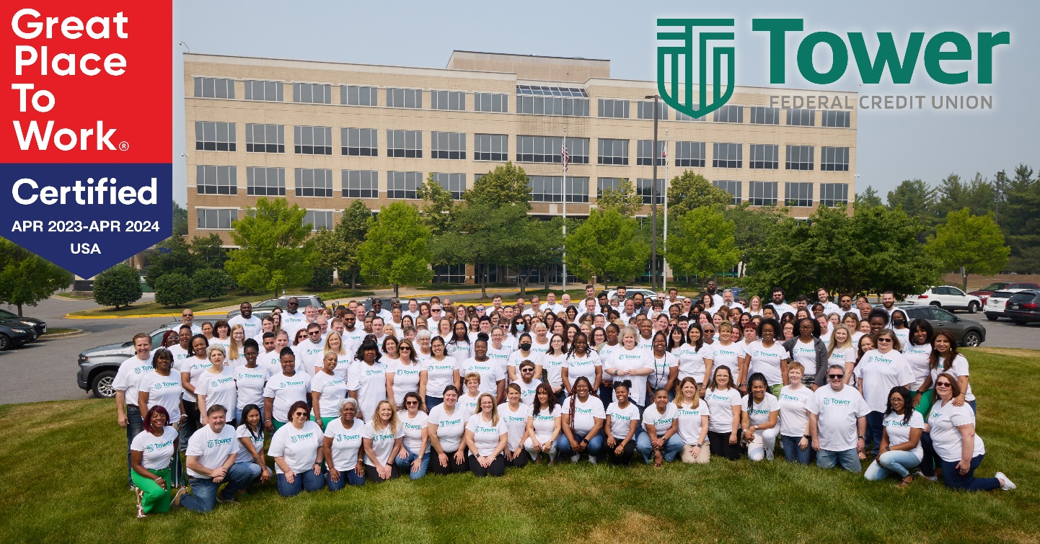

***Photo Caption:*** *Tower Federal Credit Union employees gather outside Tower’s Headquarters building in Laurel, Md. to celebrate the credit union’s recognition for the fifth year in a row as a “Great Place to Work” by the independent analysts at Great Place to Work®, an industry leader on quantifying employee experience. Tower will host an in-person Job Fair at their Laurel Headquarters on July 19, 2023 from 2 pm to 7 pm. To view current job openings, visit* [*Careers*](https://www.towerfcu.org/about/careers) *at towerfcu.org*

###

**About Tower Federal Credit Union**

[Tower Federal Credit Union](http://www.towerfcu.org/) is a member-owned, non-profit financial institution with headquarters in Laurel, MD. Established in 1953, Tower is the largest federal credit union in Maryland with over $4.5 billion in assets. It provides a full array of financial products and services and serves more than 220,000 members worldwide. Tower serves its local-area members with 12 branches in Anne Arundel, Baltimore, Howard, and Prince George’s counties and four branches at Fort Meade, as well as online services and mobile banking at towerfcu.org.