**CONTACT**

**Griffin Edwards**

**Community Engagement**

**Communications Specialist**

**541,334,8614**

[**GEdwards@MyOCCU.org**](mailto:GEdwards@MyOCCU.org)

**Date: 8.17.23**

**For immediate release**

#### **Team OCCU Hikes for Hope**

**Eugene, Oregon –** OCCU team members joined Looking Glass Community Services for its sixth annual Hike for Hope on August 5.

OCCU participated in the event for the fifth year as a sponsoring organization. As part of the sponsorship, OCCU team members and their families were invited to join in a hike up Mount Pisgah, outside Eugene.

Prior to the hike, Looking Glass held a series of raffles for items donated by other supporting organizations. Participants also heard from a Looking Glass counselor about her experiences working with at-risk youth.

Despite heat and poor air quality, many members of Team OCCU made it to the top.

In total, this year’s Hike for Hope raised $6,200. Funds will go toward Looking Glass’s work providing counseling, housing and workforce training to at-risk youth and families.

The Hike for Hope embodies OCCU’s commitment to its team members’ health through wellness policies. OCCU is proud of its generous time-off allocations, which encourage staff to step away from work to recharge often. In addition, staff are eligible for quarterly wellness reimbursements on items purchased for activities that promote mental and physical health, like exercise equipment and hobby supplies. Perhaps most notably, a pilot program was started in OCCU’s call center earlier this year to test the feasibility of a four-day, 32-hour workweek as a radical way to improve employee well-being.

OCCU has been recognized as one of the 100 Best Companies to Work For in Oregon by Oregon Business and as a Culture Innovator by Kudos Inc.

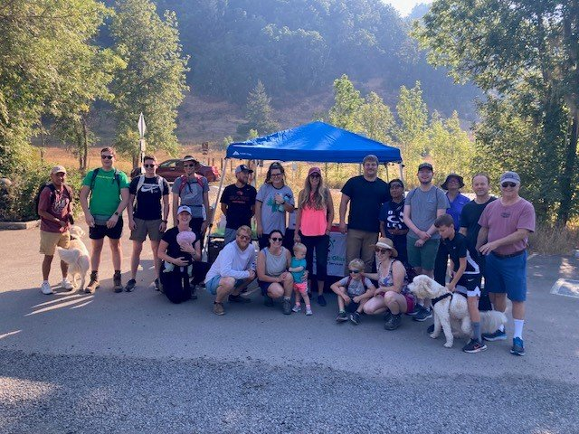

**About OCCU Foundation**

OCCU Foundation is the philanthropic arm of OCCU, a not-for-profit financial cooperative located in Oregon and Washington. Since its start, OCCU Foundation has granted more than $2.5 million to help build happier and healthier communities by giving generously to projects that advance learning, improve well-being and support communities. The foundation is a nonprofit 501(c)(3) corporation funded by OCCU, businesses, families and individuals. OCCU Foundation was founded in 2018 to further extend the credit union’s vision to Enrich Lives. Learn more at MyOCCU.org/Foundation.

**About OCCU**

OCCU is a not-for-profit financial cooperative with more than $3.4 billion in assets. The credit union was founded in Eugene, OR, in 1956, and has an expanding network of branches and web tools to provide its 269,000+ member-owners with a full suite of financial services. Membership is open to anyone living or working in 28 Oregon counties or anywhere in Washington. Learn more at [MyOCCU.org](https://myoccu.org/).

# # #