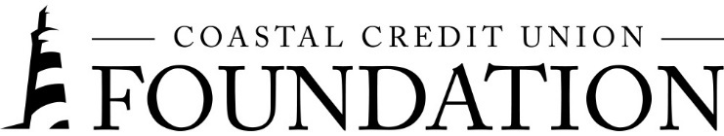**NEWS RELEASE**

Contact: Joe Mecca

VP, Communication / Spokesperson

919-420-8044 / jmecca@coastal24.com

**Final – For Immediate Release**

## **Coastal Credit Union Foundation Grant Erases $2.2 Million in Medical Debt**

**RALEIGH, N.C. (August 10, 2023) –** The [Coastal Credit Union Foundation](https://www.coastal24.com/Why-Coastal/Supporting-Our-Community/Coastal-Credit-Union-Foundation) announced that a grant to [RIP Medical Debt](https://ripmedicaldebt.org/) has helped erase nearly $2.2 million in medical debt owed by central North Carolinians. RIP Medical Debt’s purpose is to reduce the burdens of low-income individuals with limited capacity to pay their medical bills. They use donations to buy bundled debt at a steep discount and then forgive it. The organization pinpoints relief to households earning less than four times the federal poverty level or whose debts are 5% or more of their annual income.

With the foundation’s grant of $17,000 made in May 2023, RIP Medical Debt was able to buy and forgive $2,177,630.87of debt owed by 1,172 people. The program reached people in 15 of the counties that Coastal Credit Union serves.

|  |  |  |
| --- | --- | --- |
| **County** | **Recipients** | **Debt Abolished** |
| Chatham | 5 | $4,773.58 |
| Durham | 71 | $66,590.15 |
| Franklin | 52 | $71,250.27 |
| Granville | 116 | $218,323.20 |
| Halifax | 115 | $273,978.51 |
| Harnett | 58 | $69,988.66 |
| Johnston | 45 | $73,593.45 |
| Lee | 83 | $255,994.56 |
| Nash | 68 | $90,062.73 |
| Orange | 59 | $128,553.76 |
| Person | 85 | $343,226.32 |
| Vance | 95 | $194,836.17 |
| Wake | 76 | $65,694.13 |
| Warren | 118 | $228,066.93 |
| Wilson | 126 | $97,472.03 |
| **Total** | **1,172** | **$2,177,630.87** |

**About the Coastal Credit Union Foundation**

The Coastal Credit Union Foundation is a separate entity from the credit union. The mission of the Coastal Credit Union Foundation is to enrich the lives of Coastal members and their communities by providing financial support to 501(c)(3) organizations, particularly in the 16-county market of Central North Carolina. Learn more at [www.coastal24.com/foundation/](http://www.coastal24.com/foundation/).

**###**