United Federal Credit Union – Press Release
August 31, 2023

Contact: Diana Wake
Phone: (888) 982-1400 ext. 6891
Email: dwake@UnitedFCU.com
United Federal Credit Union, 150 Hilltop Road, St. Joseph, Michigan, 49085

United Federal Credit Union Names New Mortgage Advisor in Niles

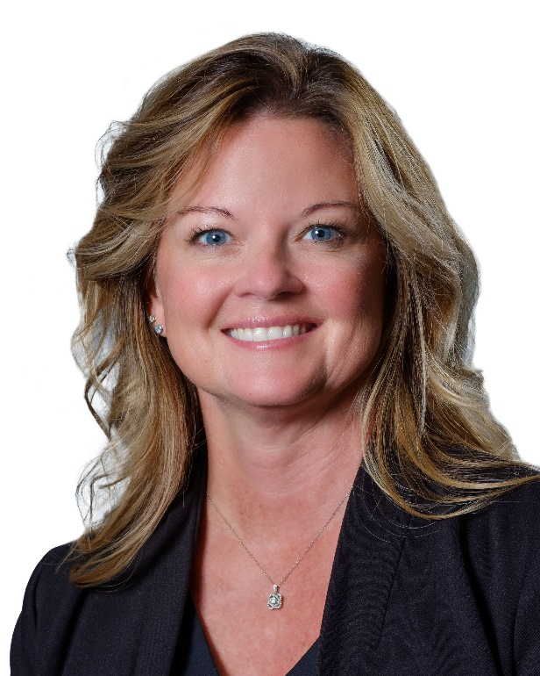
Cindy Stovern, Mortgage Advisor, Niles

NILES, Mich. – United Federal Credit Union (United) is pleased to announce the appointment of Cindy Stovern to Mortgage Advisor in Niles. Stovern is based at United’s Niles South Branch located at 2100 South 11th Street in Niles.

Stovern will use her expertise to provide a quality real estate lending experience through financial counseling and product awareness to credit union members regarding their real estate financing needs and generate investment quality mortgage loans.

Cindy Stovern began her career in the financial industry in 1992 and the mortgage lending industry since 2010. She has experience as a realtor, mortgage processor, and mortgage loan officer and pairs her industry knowledge with a passion to help people find the right mortgage option for their new home. Most recently, Stovern worked as a Senior Mortgage Loan Originator at Flagstar Bank.
____________
About United
United Federal Credit Union has served its Members since 1949 by helping them to build a sound financial future. United consists of more than 186,000 Member/owners worldwide and manages assets in excess of $3.8 billion. Its corporate office and main branch are in St. Joseph, Mich., with additional branches in Arkansas, Indiana, Michigan, Nevada, North Carolina, and Ohio. Federally insured by NCUA. Equal opportunity lender. Equal housing lender. For more information visit UnitedFCU.com

# # #

