Media Contact
Sarah Snell Cooke
sarah@cookeconsultingsolutions.com
443.472.6276

$30M HopeSouth Credit Union Makes its First Mortgage Loan
CDFI credit union building wealth in S.C.

HopeSouth Credit Union CEO Faye Crocker points out that her credit union’s service area in Abbeville County, SC, has some relatively inexpensive homes for sale. The problem often is the residents still need help to be able to afford them.
“We’re a small credit union. It’s hard to be a mortgage lender as a $30 million,” Crocker explained. But with the help of its Community Development Financial Institution certification and grants to promote, train and add a staffer, plus a partnership with Maxwell to help make members mortgage-ready, the credit union has made its very first mortgage.
The grand total of that first mortgage: $65,000.
“I’m pretty sure there was no bank standing in line to work for several months to get this young borrower mortgage ready and give him a $65,000 mortgage loan,” Crocker points out.
“We are serving a low-income demographic here in Abbeville County. A lot of our applicants are renters, and we want to help them become homeowners,” she said. In 2020, the median income in the US was $67,521 vs $43,090 in Abbeville County. And the national average home price is $416,100, compared to $199,000 in Abbeville County right now.
Homeownership is a great place to start building wealth within the community, Crocker says. “You think about those things becoming a homeowner means: They've already done some work to clean up your credit and increase their score. They're going to get better rates on car loans, which means they can afford to buy nicer cars, because they won't be paying big finance company interest rates on the car loan. Instead, they'll pay a reasonable rate, and they’ll be able to afford a home.”
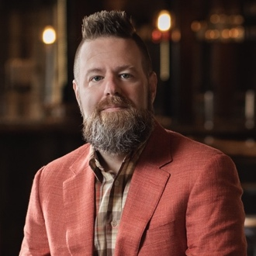
Your Marketing Co. President/CEO Bo McDonald says, “I get to say this a lot, but HopeSouth is one of my favorite clients. Faye and her team roll up their sleeves and do the work that needs to be done and no one else is willing to do. HopeSouth lives up to its brand name with this one mortgage loan. They’re providing hope in a community that thought it had been forgotten by traditional financial services providers long ago. We’d have a lot more credit unions serving people who can’t find affordable services anywhere else if we follow HopeSouth’s lead.”
# # #
Your Marketing Co., is a full-service strategic planning, branding and marketing firm serving credit unions that are not content with the status quo. Since 2008, YMC has helped dozens of credit unions grow their potential through strategy, execution and accountability. And we give a damn!

