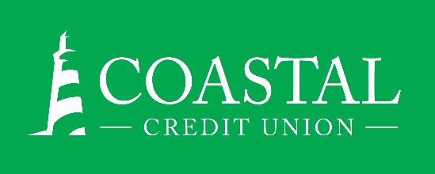**NEWS RELEASE**

Contact: Joe Mecca

VP, Communication / Spokesperson

919-420-8044 /jmecca@coastal24.com

**FINAL: For Immediate Release**

**Cooperative Block Party Draws   
Crowd to Downtown Raleigh**

**RALEIGH, N.C. (September 29, 2023) –** On Saturday, September 23,[Coastal Credit Union](https://www.coastal24.com/), [Weaver Street Market](https://www.weaverstreetmarket.coop/), and several area cooperatives hosted a [Cooperative Block Party](https://youtu.be/Ph86fEJNgxU), which was the first of its kind in the Raleigh area.

The Cooperative Block Party was created to exemplify the sixth of the [eight cooperative principles](https://carolinasfoundation.org/cooperative-principles/), *Cooperation Among Cooperatives*. It was a chance for residents to learn what cooperatives are, and to meet the different types of cooperatives that deliver essential goods and services to our community. Participants included: Coastal Credit Union, Weaver Street Market, Cabot Creamery Cooperative, Equal Exchange, State Employees Credit Union, Civic Credit Union, Daymark Realty, Cooperative Council of North Carolina, Burny Wild’s Adventure Sauce, The Art of Cheese Carving, NC Electric Cooperatives, and Carolinas Telco Federal Credit Union.

The event was scheduled to take place on the 400 block of West Hargett Street. Due to Tropical Storm Ophelia, it was moved into the café area inside Weaver Street Market’s downtown Raleigh location. It featured family-friendly games and free activities, an onsite cheese carver, raffle prizes, and more. The first 300 families received a cooler grocery tote, a $10 lunch voucher and swag at the Coastal Credit Union table at each entrance.

**About Coastal**

Coastal Credit Union is a not-for-profit, member-owned, financial cooperative, offering a full range of financial products and services. Coastal was chartered on August 31, 1967, with the mission of fostering the credit union philosophy of “people helping people.”  Today, with $4.85 billion in assets, Coastal serves 330,000 members from 1,800 business partners and is among the leading financial institutions in North Carolina.  Coastal operates 24 locations in central North Carolina and serves members in all 50 states through a network of 5,600 shared branches, 30,000 surcharge-free ATMs, mobile banking featuring mobile check deposit, and a robust offering of online services at [www.COASTAL24.com](http://www.coastal24.com/). For more Coastal news, visit our [online newsroom](https://www.coastal24.com/Why-Coastal/Inside-Coastal/Newsroom).

**###**