FOR IMMEDIATE RELEASE
MEDIA CONTACT:
Larry Meltzer
larry.meltzer@mm2pr.com
214.536.7456

Sacramento Valley Credit Union Network Supports MIND Institute at UC Davis Health
Toys, games and activity books will benefit children with neurodevelopmental disabilities at UC Davis Health MIND Institute

Sept. 26, 2023 – Representatives of the Sacramento Valley Credit Union Network, a regional extension of the California Credit Union League (CCUL), brightened the day at the MIND Institute of UC Davis with a donation of toys, games and activity books for children undergoing treatment for neurodevelopmental disabilities at the institute’s clinic. The UC Davis Children’s Hospital is part of the Children’s Miracle Network Hospitals, which is supported as the charity of choice by credit unions across the country.
Members of the Sacramento Valley Credit Union Network that participated in the collection and donation of the materials included team members from SchoolsFirst Federal Credit Union, Travis Credit Union, First US Community Credit Union, SAFE Credit Union, Golden 1 Credit Union and Sierra Central Credit Union.
“All credit unions have a firm commitment to give back to their communities,” said Dalia Velazquez, Orangevale branch manager for SchoolsFirst FCU and chairperson of the Sacramento Valley Credit Union Network. “The Sacramento Valley Credit Union Network is proud to partner with Children’s Miracle Network Hospitals to benefit children and families in our region.”
# # #

About SchoolsFirst Federal Credit Union:
SchoolsFirst Federal Credit Union is the fifth largest credit union in the country and has been recognized by Forbes as the number one credit union in California. Serving school employees and their families, the organization is dedicated to delivering World-Class Personal Service and improving the financial lives of its Members. Today they serve more than 1.3 million Members with a full range of financial products and services. SchoolsFirst FCU was founded in 1934, when 126 school employees pooled $1,200 and established a Member-owned cooperative to help improve each other's lives. In 2022, the Credit Union reported nearly $28 billion in assets and remains the largest credit union in California. For more information about SchoolsFirst Federal Credit Union, visit schoolsfirstfcu.org.

Insured by NCUA

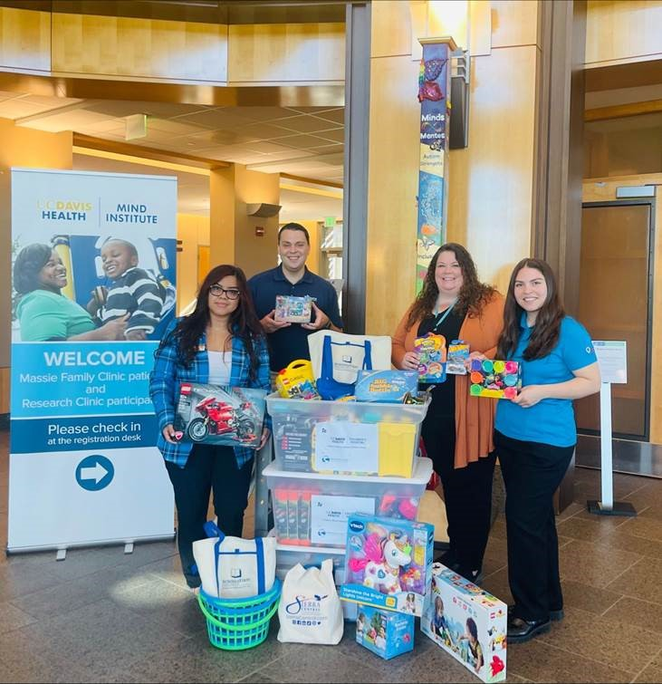
PHOTO CUTLINE:
Members of the Sacramento Valley Credit Union Network deliver toys, games and activity books to the MIND Institute of UC Davis Children’s Hospital.
Left to right: Dalia Velazquez, Orangevale Branch Manager, SchoolsFirst Federal Credit Union; Damian Alarcon, Community Development and Government Relations Director, Travis Credit Union; Erin Roseborough, CCLS Child Life Specialist II, UC Davis MIND Institute; Chelsea Dominguez, Program Coordinator, Children’s Miracle Network.

