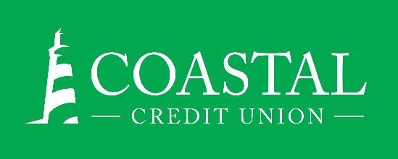**NEWS RELEASE**

Contact: Joe Mecca

VP, Communication / Spokesperson

919-420-8044 /jmecca@coastal24.com

**Final: For Immediate Release**

## **Coastal Credit Union Named Among Triangle’s Healthiest Employers for the 13th Time**

**RALEIGH, N.C. (October 11, 2023) –** [Coastal Credit Union](https://www.coastal24.com/) has been recognized as one of the [Healthiest Employers of the Triangle for 2023](https://www.healthiestemployers.com/healthiest-employers-events/triangle).

Healthiest Employers is an awards program that recognizes people-first organizations that are focused on improving the health of their employees by creating a community invested in their populations' health and well-being. Award applicants were evaluated across six key categories: Culture and Leadership, Foundational Components, Strategic Planning, Communication and Marketing, Programming and Interventions, and Reporting and Analytics.

This is the 13th time that Coastal has been named a Healthiest Employer of the Triangle, including the past eight years in a row. It is one of four workplace awards that the credit union has earned this year.

**About Coastal**

Coastal Credit Union is a not-for-profit, member-owned, financial cooperative, offering a full range of financial products and services. Coastal was chartered on August 31, 1967, with the mission of fostering the credit union philosophy of “people helping people.”  Today, with $4.85 billion in assets, Coastal serves 331,000 members from 1,800 business partners and is among the leading financial institutions in North Carolina. Coastal operates 24 locations in central North Carolina and serves members in all 50 states through a network of 5,600 shared branches, 30,000 surcharge-free ATMs, mobile banking featuring mobile check deposit, and a robust offering of online services at [www.COASTAL24.com](http://www.coastal24.com/). For more Coastal news, visit our [online newsroom](https://www.coastal24.com/Why-Coastal/Inside-Coastal/Newsroom).

**###**