CONTACT
Griffin Edwards
Community Engagement
Communications Specialist
541.334.8614
GEdwards@MyOCCU.org

Date: 10.5.23
For immediate release

OCCU Foundation’s contributions topped $900,000 in 2022

Eugene, Oregon – OCCU Foundation distributed $919,497 to nonprofits and charitable initiatives in 2022, the largest annual total in its five-year history.

According to the foundation’s recently published 2022 impact report, which details the many projects it supported during the year, 49% of the foundation’s contributions went toward health-related causes, 27% toward education and 24% toward community-building initiatives.

Among the projects that OCCU Foundation supported in 2022 were:

  - FOOD for Lane County’s Summer Food Program. During the summer, a gap in nutrition services opens as school lunches are not available. OCCU Foundation’s grant provided 7,800 meals for area families at risk of food insecurity in Eugene, Springfield and surrounding rural areas.
  - The Eugene Family YMCA. OCCU Foundation has partnered with the Eugene Family YMCA to sponsor the Youth Learning Lab, a flexible space for K-12 students to explore STEM (science, technology, engineering and mathematics) fields and engage their creativity. It will also be the epicenter for youth programs ranging from summer camps to after-school care.
  - Scholarships for higher education. In 2022, OCCU Foundation funded $225,750 in scholarships for Oregon students. Recipients include first-generation and low-income students who major in a variety of subjects, including nursing and education, at institutions ranging from community colleges to the University of Oregon.

“We’re pleased to support so many programs and nonprofit agencies in our region in their work to help our communities thrive,” said Ron Neumann, OCCU president & CEO and OCCU Foundation chair. “We are grateful for the support we have received, and we look forward to new opportunities to positively impact our community in the years ahead.”

The OCCU Foundation is funded through a combination of corporate philanthropy and outside contributions. A portion of contributions come from OCCU employees and through an annual golf tournament. In 2022, the tournament raised more than $190,000 to support local food security initiatives for children and families.

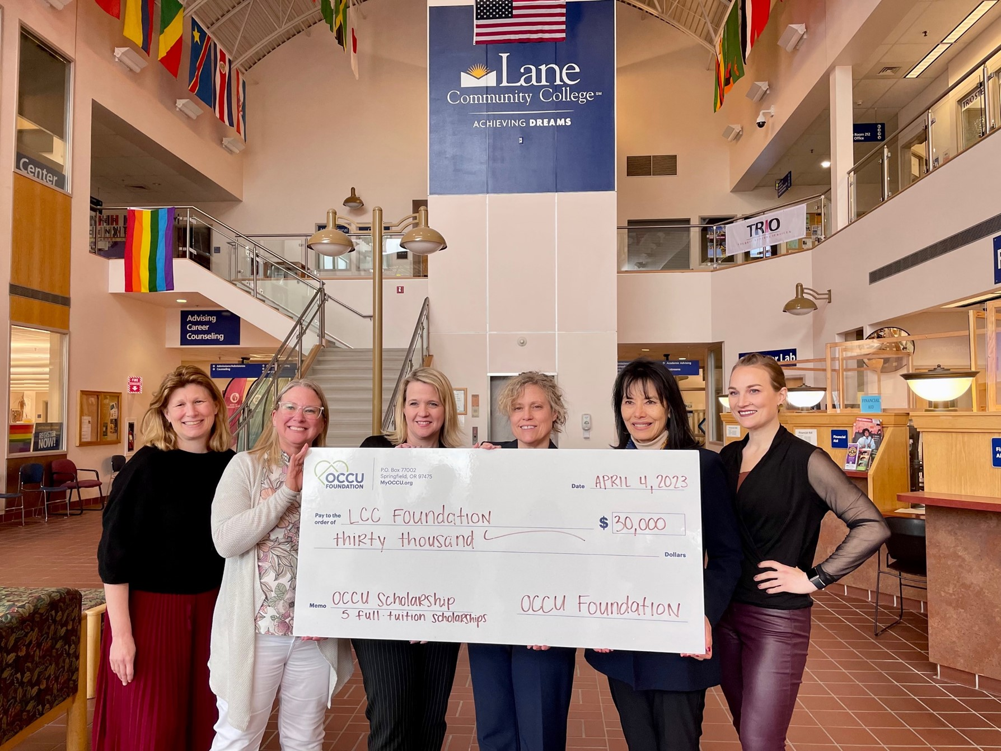
OCCU’s Tracy Keffer and Heather Billings (second and third from left) present Lane Community College Foundation representatives with $30,000 in scholarship funds. OCCU Foundation funded five full-ride scholarships in 2022. Keffer is OCCU’s chief operating officer and a member of the OCCU Foundation board. Billings is OCCU’s chief marketing officer and secretary of the OCCU Foundation board.

About OCCU Foundation
OCCU Foundation is the philanthropic arm of OCCU, a not-for-profit financial cooperative located in Oregon and Washington. Since its start, OCCU Foundation has granted more than $2.5 million to help build happier and healthier communities by giving generously to projects that advance learning, improve well-being and support communities. The foundation is a nonprofit 501(c)(3) corporation funded by OCCU, businesses, families and individuals. OCCU Foundation was founded in 2018 to further extend the credit union’s vision to Enrich Lives. Learn more at MyOCCU.org/Foundation.

About OCCU
OCCU is a not-for-profit financial cooperative with more than $3.4 billion in assets. The credit union was founded in Eugene, OR, in 1956, and has an expanding network of branches and web tools to provide its 271,000+ member-owners with a full suite of financial services. Membership is open to anyone living or working in 28 Oregon counties or anywhere in Washington. Learn more at MyOCCU.org.
# # #

