***FOR IMMEDIATE RELEASE***

*CONTACT:*

*Julie Woloszyn, PCM, CWCUL*

*Marketing Manager*

*Corporate Central Credit Union*

*(414) 425-5555*

**Corporate Central Gears Up for 2024 with Economic Outlook Conference Featuring Four Distinguished Presenters**

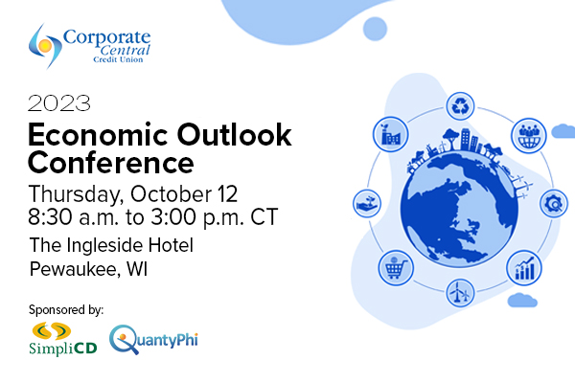**MILWAUKEE, WI – October 18, 2023** – Corporate Central is proud to announce the successful conclusion of its Economic Outlook Conference, a pivotal event designed to empower member credit unions with the knowledge and insights needed to navigate the complex financial landscape of 2024. This premier conference brought together experts and leaders from the credit union industry to provide invaluable guidance and forecasts for the year ahead.

Held on Thursday, October 12 at The Ingleside Hotel in Pewaukee, WI, the conference was a resounding success, delivering on its promise to be a must-attend event for credit union professionals seeking to proactively address economic challenges and opportunities.

**Conference highlights:**

The conference featured a diverse lineup of presenters, each sharing their expertise and unique perspectives.

1. **Clare Zempel, CFA, CBE,** Principal of Zempel Strategic presented, “Economic and Financial Outlook: 2023-2028.”During his presentation, he talked about how the Federal Reserve’s sharp interest rate hikes will subdue inflation with or without a recession. Both the inflation rate and the economic expansion’s pace have clearly slowed. Some sectors have suffered sharp declines, but total employment and Real GDP have continued to rise. Zempel shared his thoughts on whether 2023 end in a “soft landing” or a recession and whether 2024 will see an economic rebound and more normal yield spreads.
2. **Mike Schenk**, Deputy Chief Advocacy Officer for Policy Analysis and Chief Economist at CUNA, presented, “On the Brink?” Federal Reserve policies have put the economy on the brink of recession. Politics and the divisive political climate have assumed increasing importance. De-globalization and military conflict dominate the international scene. Uncertainty, complexity, and volatility seem here to stay. Against this backdrop, the credit union operating environment is more challenging. Many institutions are reporting big declines in loan growth, eroding asset quality, and weaker earnings. Schenk explored these and related themes and discussed implications for credit unions.
3. **Jim Bianco**, Macro Strategist and President of Bianco Research, LLC, presented, “Outlook for Interest Rates, Inflation, and the Economy.” During his presentation, Bianco talked about how the last few years have seen unprecedented volatility in interest rates, with the Fed hiking over 500 basis points, inflation hitting a 40-year high, and the real economy dipping into negative growth (Q1 and Q2 2022). Add to this de-globalization, remote work, and a struggling Chinese economy, and the outlook for what comes next is murky, to say the least. Looking ahead requires a challenge to the traditional relationships and models that worked pre-pandemic in this post-pandemic world.
4. **Frank J. Diekmann**, Cooperator-in-Chief and Co-Founder of CUToday.info, closed out the day sharing “25 Ideas That Are Working in Credit Unions.” Regardless of asset size, successful credit unions share the common traits of imagination and innovation. Budget is not the most important factor. Diekmann highlighted 25 successful credit union programs that have proven to be effective. He touched on topics such as: lending promotions, new membership campaigns, savings ideas, culture builders, onboarding initiatives, and more. All kinds of different challenges that have been met with one thing in common: a willingness to take chances, have fun, and do things differently.

"The success of this conference demonstrates our unwavering commitment to empowering credit unions and ensuring their success in an ever-changing financial landscape," said Kevin Chiappetta, CFA, Senior Vice President Investment Services who moderated the event. "We are truly grateful for the support of our sponsors, SimpliCD (Primary Financial) and QuantyPhi, and for the dedication of our attendees and presenters in making this event a resounding success."

**About SimpliCD (Primary Financial)**

*Founded in 1996, Primary Financial is a credit union service organization (CUSO) jointly owned by 10 corporate credit unions, primarily serving natural-person credit unions nationwide with CD investments and issuance. A leader in the CD industry, Primary Financial is a registered broker dealer in the state of Ohio and has offices in Dublin, Ohio, and Columbus, Indiana. To learn more, visit* [*epfc.com*](http://www.epfc.com/)*.*

**About QuantyPhi, LLC**

*QuantyPhi, LLC is a wholly owned credit union service organization. The CUSO specializes in credit union balance sheet optimization. QuantyPhi’s mission is to build better credit unions by building balance sheets with muscle, flexibility, and resilience. Please visit* [*QuantyPhi.com*](https://www.quantyphi.com/?utm_source=quantyphi&utm_medium=press_release&utm_campaign=post_quantyphi_strategic_alm_conference_pr) *to learn more and follow us on* [*LinkedIn*](https://www.linkedin.com/company/quantyphi/)*.*

**Helping Members to be *Wildly* Successful**

**About Corporate Central Credit Union**

*Corporate Central Credit Union is a federally insured financial cooperative built on the values of commitment to service, fiscal responsibility, and respect for the individual. We cultivate a culture of respect, ethics, teamwork, and innovation. We are "Helping Members to be Wildly Successful" by delivering industry knowledge and expertise to help credit unions achieve their strategic objectives and compete in today’s evolving financial services industry. We are motivated to passionately serve our members and strive to learn, create, and innovate daily. Please visit* [*corpcu.com*](http://www.corpcu.com) *to learn more, and follow us on* [*Facebook*](https://www.facebook.com/CorporateCentral)*,* [*LinkedIn*](https://www.linkedin.com/company/517350/)*,* [*Twitter*](https://twitter.com/CorpCU)*, and* [*YouTube*](https://www.youtube.com/channel/UCLt6UMRaRkpGF-qWWx8T94w)*.*