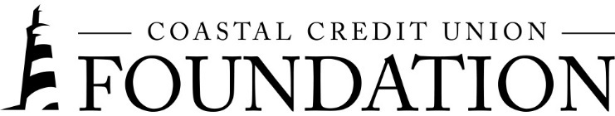**NEWS RELEASE**

Contact: Joe Mecca

VP, Communication / Spokesperson

919-420-8044 / jmecca@coastal24.com

**FINAL: For Immediate Release**

**Coastal Credit Union Foundation Gives Three New Grants to North Carolina Nonprofits**

**RALEIGH, N.C. (November 21, 2023) –** [The Coastal Credit Union Foundation](https://www.coastal24.com/Why-Coastal/Supporting-Our-Community/Coastal-Credit-Union-Foundation) announced today that it has awarded $78,500 to three nonprofits in North Carolina. The Foundation prioritizes funding projects in four key areas: promoting financial well-being, increasing affordable housing, supporting financial education, and improving access to resources.

In 2023 alone, the Foundation has provided $953,800 to a wide variety of nonprofit organizations that directly impact local communities.

The Foundation’s most recent grantees include:

**Access to Resources**

* The Senior Network, Inc.

**Affordable Housing**

* Hope Renovations

**Financial Well-Being**

* NC Council on Economic Education

“It is our joy to support North Carolina nonprofits through our grant funding program,” said Emily Nail, executive director of the Foundation. “The spirit of giving back is part of Coastal’s mission every day – not just during the holidays. These three new grants will provide much needed assistance to local individuals and we’re continuously proud to be part of the difference that these nonprofits are making in people’s lives.”

**About the Coastal Credit Union Foundation**

The Coastal Credit Union Foundation is a separate entity from the credit union. The mission of the Coastal Credit Union Foundation is to enrich the lives of Coastal members and their communities by providing financial support to 501(c)(3) organizations, particularly in the 16-county market of Central North Carolina. Learn more at [www.coastal24.com/foundation/](http://www.coastal24.com/foundation/).

**###**