

United Federal Credit Union – Press Release
November 28, 2023

Contact: Diana Wake
Phone: (888) 982-1400 ext. 6891
Email: dwake@UnitedFCU.com
United Federal Credit Union, 150 Hilltop Road, St. Joseph, Michigan, 49085

United Federal Credit Union Promotes Kimberly Triana Branch Manager in Hendersonville
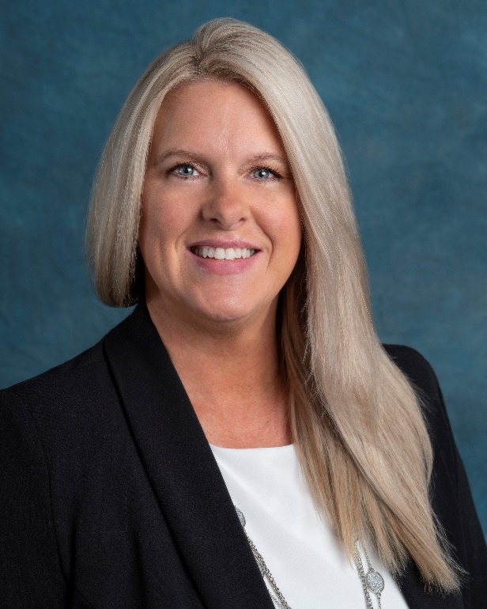
Kimberly Triana, Branch Manager, Hendersonville South

HENDERSONVILLE, N.C. – United Federal Credit Union (United) has promoted Kimberly Triana as Branch Manager at its branch at 203 Greenville Hwy in Hendersonville.

As Branch Manager, Triana will be responsible for maintaining the performance of the branch and providing leadership and supervision to staff.

Triana brings more than 20 years of financial and customer service experience to her new role. She started with United in 2021 and has held multiple roles within the credit union, including Teller and Member Service Advisor. She is looking forward to continuing to assist our Members and serving the Hendersonville community.
____________
About United
United Federal Credit Union has served its Members since 1949 by helping them to build a sound financial future. United consists of more than 186,000 Member/owners worldwide and manages assets in excess of $3.8 billion. Its corporate office and main branch are in St. Joseph, Mich., with additional branches in Arkansas, Indiana, Michigan, Nevada, North Carolina, and Ohio. Federally insured by NCUA. Equal opportunity lender. Equal housing lender. For more information visit UnitedFCU.com

# # #

