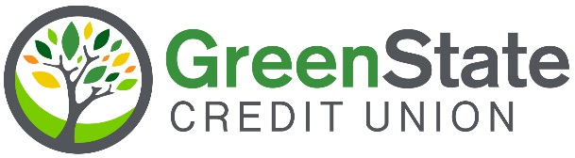

Media Release
Contact: Ryan Doehrmann, Chief Mortgage Officer
RE: GreenState continues to help more BIPOC Iowans own their homes
Date: December 8, 2023
CC:
GreenState Credit Union surpasses $500 million in mortgage lending to BIPOC Iowans
NORTH LIBERTY, Iowa — Many Iowans are enjoying this holiday season in a new home, thanks to GreenState Credit Union’s goal of investing $1 Billion in mortgage lending to BIPOC Iowans. Just three years into their ambitious 10-year goal to close the racial homeownership gap, GreenState announced they have surpassed the halfway mark.
Dubbed the H.O.M.E. Program (Helping Originate Minority Equity), GreenState has successfully assisted a total of 3,190 families in securing mortgage loans, amounting to more than $532 million in mortgages for Iowans of color. In addition to modifying the loan approval process to make these loans more accessible, the GreenState Foundation has generously provided over $980,000 in down payment assistance grants to those who qualify. By offering this additional support, GreenState is helping to build stronger communities across the state.
"We are thrilled to celebrate the incredible milestone for our communities," said Ryan Doehrmann, Chief Mortgage Officer of GreenState Credit Union. "This achievement is a tribute to the dedication and hard work of our team, as well as the invaluable support from our community partners. We remain committed to our goal of making homeownership a reality for even more Iowans in the years to come, helping families build equity and generational wealth."
About GreenState Credit Union
GreenState Credit Union is Iowa’s largest credit union and one of the top financial institutions in the United States for returning profits to members in the form of better rates and lower fees. GreenState serves over 447,000 members with 33 branch locations. Membership is open to anyone living or working in Iowa as well as select counties in Illinois, Wisconsin, Nebraska, and South Dakota. For more information or to become a member, visit www.greenstate.org. The credit union actively supports various local initiatives, including financial literacy programs, scholarships, and community development projects, investing nearly $10 million in charitable giving over the past three years. Their dedication to improving the lives of Iowans is evident in their ongoing efforts to create a brighter future for all.

