

***FOR IMMEDIATE RELEASE***

*CONTACT:*

*Julie Woloszyn,* *PCM, CWCUL,* *CCUFC*

*Marketing Manager*

*Corporate Central Credit Union*

*(414) 425-5555*

**Corporate Central Employees Make a Difference at Hope Center**

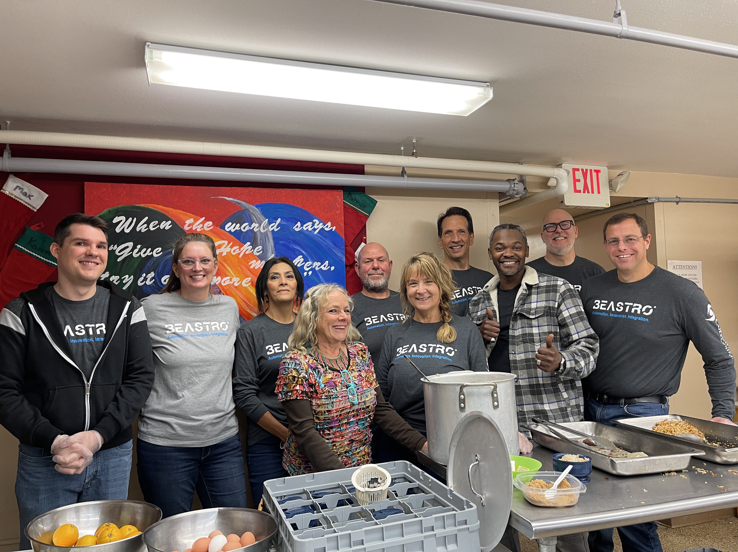**MILWAUKEE, WI – December 18, 2023** – Corporate Central demonstrated its commitment to community service and philanthropy last week as eight dedicated employees volunteered their time at the [Hope Center](https://hopecenterwi.org/) in Waukesha, WI. Hope Center is a non-profit organization that has been serving the basic needs of financial assistance, food, and clothing in Waukesha County for more than thirty years.

The employees selflessly devoted their time to serving breakfast to those in need. Their hands-on involvement reflects Corporate Central’s core values of social responsibility and community engagement.

Corporate Central employees volunteer serving breakfast at Hope Center in Waukesha, WI.

"We understand the importance of supporting organizations like Hope Center, that play a vital role in addressing hunger and fostering a sense of community," said Amy Nowak, HR Generalist. "Our employees are not just part of a workforce; they are members of a larger community, and it is our responsibility to contribute positively to the lives of those around us. Volunteering at the Hope Center aligns perfectly with our values, and we are grateful for the opportunity to make a meaningful impact."

In addition to the volunteer efforts, Corporate Central donated $1,000 to further bolster the Hope Center’s meal program. This financial contribution will help ensure that individuals and families in the Waukesha community have access to nutritious meals, particularly during challenging times.

Interested in volunteering with Corporate Central at future events? Please send an email to [volunteer@corpcu.com](mailto:volunteer@corpcu.com).

**Helping Members to be *Wildly* Successful**

**About Corporate Central Credit Union**

*Corporate Central Credit Union is a federally insured financial cooperative built on the values of commitment to service, fiscal responsibility, and respect for the individual. We cultivate a culture of respect, ethics, teamwork, and innovation. We are "Helping Members to be Wildly Successful" by delivering industry knowledge and expertise to help credit unions achieve their strategic objectives and compete in today’s evolving financial services industry. We are motivated to passionately serve our members and strive to learn, create, and innovate daily. Please visit* [*corpcu.com*](http://www.corpcu.com) *to learn more, and follow us on* [*Facebook*](https://www.facebook.com/CorporateCentral)*,* [*LinkedIn*](https://www.linkedin.com/company/517350/)*,* [*Twitter*](https://twitter.com/CorpCU)*, and* [*YouTube*](https://www.youtube.com/channel/UCLt6UMRaRkpGF-qWWx8T94w)*.*