**CONTACT**

**Griffin Edwards**

**Community Engagement**

**Communications Specialist**

**541.334.8614**

[GEdwards@MyOCCU.org](mailto:GEdwards@MyOCCU.org)

**Date: 1.4.24**

**For immediate release**

#### **OCCU celebrates its biggest volunteer year**

**Eugene, Oregon –** OCCU team members volunteered more than 4,500 hours in 2023, the biggest year yet for employee volunteerism.

Staff logged the time through an OCCU program that provides employees with 40 hours of paid time each year to volunteer in the community. Team members are encouraged to find causes that they are passionate about, and OCCU’s Community Engagement team promotes regular volunteer opportunities for all staff.

The program — known as Community OutReach for Employees (CORE) — saw a total of 4,563 hours for 2023, an average of about 7.6 per employee and roughly 12.5 for each day. This is almost double the past record year of 2,600 hours. This is also a notable jump from 2022 when staff logged 945 hours, a number influenced by the effects of the COVID-19 pandemic.

Popular local nonprofits included Ronald McDonald House Charities, FOOD for Lane County and Cornerstone Community Housing. Volunteers represent all departments at OCCU, from branch staff to technology specialists to members of the leadership team.

“Volunteers like Team OCCU make it possible for us to achieve our goal: to create a home away from home for families experiencing medical crises,” said Robin Yozzo, director of the Ronald McDonald Heartfelt House in Springfield, Oregon. “OCCU staff have cooked dinner for our guest families since our doors opened in 2019. We cannot do what we do best without volunteers like them, and for this, we are truly grateful!”

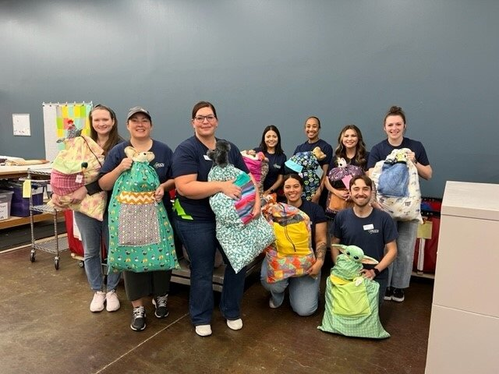

*A team from OCCU organizes comfort bags for children in need for local nonprofit Bags of Love.*

**About OCCU**

OCCU is a not-for-profit financial cooperative with more than $3.4 billion in assets. The credit union was founded in Eugene, OR, in 1956, and has an expanding network of branches and web tools to provide its 271,000+ member-owners with a full suite of financial services. Membership is open to anyone living or working in 28 Oregon counties or anywhere in Washington. Learn more at [MyOCCU.org](https://myoccu.org/).

# # #