January 10, 2024
FOR IMMEDIATE RELEASE

Contact:
Kelli Briggs, SESLOC Credit Union
(805) 543-1816 ext. 210
kbriggs@sesloc.org

SESLOC President & CEO Announces Retirement

SAN LUIS OBISPO, Calif.— SESLOC Credit Union announced today that Geri LaChance will retire as President and CEO effective June 2024 after 12 years of leadership at the credit union. LaChance will be succeeded by Executive Vice President/Chief Financial Officer Mike Quamma.
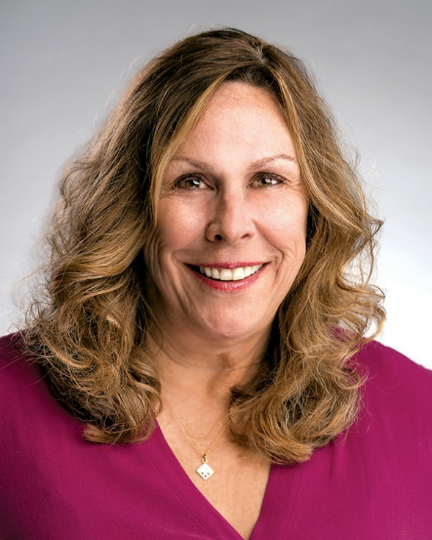
"It’s hard to aptly summarize the legacy Geri will leave at SESLOC after 12 years at the helm of the credit union. She will leave SESLOC well-positioned for the future thanks to the myriad of changes she has championed. During her tenure, the credit union grew to over $1.2 billion in assets and garnered frequent, regular recognition and accolades from the community and the credit union industry. Her political advocacy, statewide and nationally, has helped to protect the important role that credit unions play in people's lives. But equally important is the indelible stamp she has made on the workplace at SESLOC. Great company culture is no accident. Geri has set the tone and expectation at the top that SESLOC must be, above all, a great place to work,” said Tom Lebens, SESLOC Board Chair.

LaChance led SESLOC’s technology infrastructure in place today which includes robust systems and a keen focus on digital technologies that enhance the ease of doing business with SESLOC. Additionally, she championed the construction of SESLOC’s new headquarters that opened in 2014, as well as getting SESLOC back on the Cal Poly campus. Geri’s impact on the Central Coast is extensive, earning accolades such as “Top 50 Women in Business,” “Best Places to Work” and “50 Fastest Growing Companies.”

LaChance is active in the local Central Coast community; she is a member of the Cal Poly Corporation Board, Chair of the Foundation for Performing Arts Council (FPAC), board member and past chair for the SLO County YMCA, and advisory board member to the REACH Council on Central Coast regionalism. Geri is past chair of the SLO Chamber of Commerce, past member of the SLO Food Bank and previously served as a board member with Leadership SLO and the SLO Housing Trust Fund.

Advocating for growth of the credit union movement is something that LaChance has done numerous times in her 36-year career. Her unwavering dedication to equity and inclusion shined a light on a global credit union movement in the late nineties. The Polish Credit Union was in its infancy as it was forming after the fall of Communism. She was instrumental in the “Twinning Program,” where she mentored and facilitated partnerships between U.S. credit unions and their newly forming Polish counterparts.

Geri currently serves as Chair of the California Credit Union League (CCUL), representing 277 Credit Unions with $291 billion in assets. She was the 2022 Co-chair of the Credit Unions for Kids Wine Auction, benefitting Children’s Hospitals in California and Nevada, which raised $1.5 million for Children’s Miracle Network at the gala/auction. Geri was named the CCUL’s Advocate of the Year in 2021 for political grassroots support.

Tom Lebens shared, “Geri will be deeply missed, but her retirement is richly deserved. We all thank Geri for her wonderful and impactful leadership at SESLOC.”

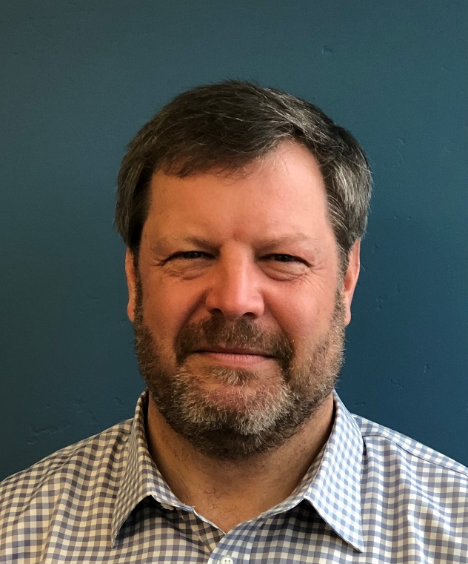
“The board is delighted to announce that Mike Quamma, our Chief Financial Officer, has been selected as the new Chief Executive Officer of SESLOC Credit Union. Mike has been with SESLOC since March of 2020, and has been instrumental in ensuring the financial stability and resilience of our credit union during the challenging times of the pandemic and its aftermath. Mike brings to his new role nearly 30 years of credit union experience, including senior positions at Seattle Credit Union and Boeing Employees Credit Union. Mike has also been a visionary leader in developing and implementing our long-term growth plans and strategic initiatives, with a focus on enhancing our products, services, and digital capabilities for our members,” said Tom Lebens, Board Chair.

Mike Quamma came to SESLOC with three decades of credit union industry experience, including 27 years at Boeing Employees Credit Union (BECU) in various financial roles. BECU is the fourth largest credit union in the United States, with $22 billion in assets and one million members. This deep experience, coupled with the fact he’s a savvy, inquisitive, and perceptive partner to colleagues at SESLOC, is a winning combination.

One of the most important traits SESLOC’s next CEO has to possess is the desire and ability to build upon the great culture at SESLOC. Quamma’s ready sense of humor, love of teaching, belief in the credit union mission and vision for the future will serve him well in this regard. Mike will also continue deep involvement in the local community, currently serving on the Board of the SLO Food Bank as the Treasurer, the SLO Chamber Economic Development Committee, and the SLO Downtown Association Finance Committee. Mike is a recent Class 31 Leadership SLO graduate.

About SESLOC
SESLOC is a not-for-profit financial institution on California’s central coast since 1942, now operating with six branches in San Luis Obispo, Paso Robles, Atascadero, Arroyo Grande, Santa Maria and at the Cal Poly campus. With assets of $1.2 billion, their 170 employees provide valuable financial and educational services to 59,000 members. SESLOC membership is open to anyone who lives, works or goes to school in San Luis Obispo or Northern Santa Barbara Counties. For more information, please visit www.sesloc.org.

###

