United Federal Credit Union – Press Release
January 22, 2024

Contact: Diana Wake
Phone: (888) 982-1400 ext. 6891
Email: dwake@UnitedFCU.com
United Federal Credit Union, 150 Hilltop Road, St. Joseph, Michigan, 49085

United Federal Credit Union Promotes Three to Director Roles to Start New Year

ST. JOSEPH, Mich. – United Federal Credit Union (United) in St. Joseph, Michigan, announced the promotion of three current employees to director level positions in 2024.

Bob Beauchamp, Director of Learning and Development

Bob Beauchamp has been promoted to Director of Learning and Development. In his new role, he will lead United’s Learning and Development team and initiatives. Beauchamp will partner with business leaders to assess training needs and design, develop, and implement solutions to drive organizational results.

Beauchamp has been with United since 2006. He has held many roles, including Call Center Member Service Advisor, Training Specialist, and most recently, Instructional Design Manager.

Katrina Leach, Director of Digital Banking

Katrina Leach has been promoted to Director of Digital Banking. Leach will be responsible for managing the digital product/service delivery life cycle at the credit union from strategic planning, tactical launches, and operations in support of all digital channels for all retail and business members. She will lead and guide efforts by prioritizing, designing, developing, and supporting new and existing products and services.

Leach has been with United since 2012. She has worked in multiple departments and has held several roles, including Teller, Floor Supervisor, Manager Member Sales and Services, and most recently, Digital Operations Manager.

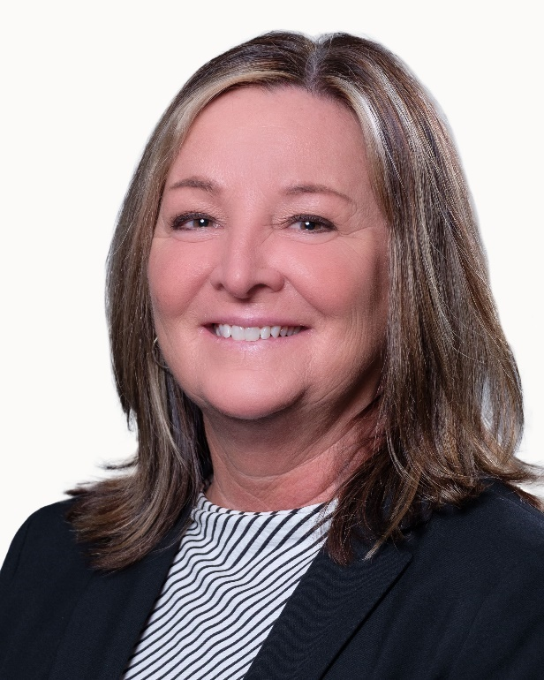
Laura Sinclair, Director of Consumer Lending

Laura Sinclair has been promoted to Director of Consumer Lending. In her new role, she will oversee Consumer and Equity Underwriting, Indirect Funding, and Equity Processing. She will be responsible for the day-to-day operations of those teams including coaching, performance management, onboarding, and scheduling.

Sinclair started with United in 1993 as part of Gast Employees Credit Union. She’s worked on the frontline with Members as a Member Service Advisor and Assistant Branch Manager, before moving into the lending team and holding several positions. Most recently she was Consumer Lending Manager.
____________
About United
United Federal Credit Union has served its Members since 1949 by helping them to build a sound financial future. United consists of more than 186,000 Member/owners worldwide and manages assets in excess of $3.8 billion. Its corporate office and main branch are in St. Joseph, Mich., with additional branches in Arkansas, Indiana, Michigan, Nevada, North Carolina, and Ohio. Federally insured by NCUA. Equal opportunity lender. Equal housing lender. For more information visit UnitedFCU.com

# # #

