

**United Federal Credit Union – Press Release**

March 4, 2024

Contact: Diana Wake

Phone: (888) 982-1400 ext. 6891

Email: [dwake@UnitedFCU.com](mailto:dwake@UnitedFCU.com)

United Federal Credit Union, 150 Hilltop Road, St. Joseph, Michigan, 49085

**United Federal Credit Union Names Jennifer Strefling Director of Internal Audit**

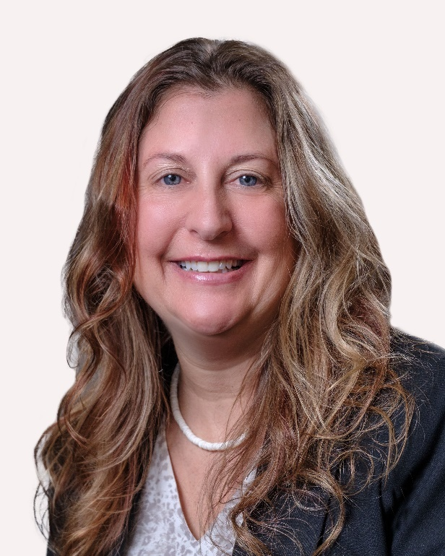

*Jennifer Strefling, Director of Internal Audit*

**ST. JOSEPH, Mich. –** United Federal Credit Union (United) has appointed Jennifer Strefling as Director of Internal Audit at its corporate headquarters in St. Joseph, Michigan.

Strefling brings more than two decades of experience in financial institution examination and compliance management to her role. Most recently, she was a Financial Institution Examiner at the Department of Insurance and Financial Services. Strefling previously spent 15 years with United as its Loss Mitigation Specialist.

In her new role, Strefling will lead United’s audit team in the identification of risk, evaluating internal control design, and examining administration of internal control processes. She will also serve as the liaison with regulators and external audit resources for the credit union.

Strefling studied at Bethel University in Indiana where she earned a bachelor’s degree and has the BSACS (CUNA) certification.

**____________**

**About United**

United Federal Credit Union has served its Members since 1949 by helping them to build a sound financial future. United consists of more than 186,000 Member/owners worldwide and manages assets in excess of $3.8 billion. Its corporate office and main branch are in St. Joseph, Mich., with additional branches in Arkansas, Indiana, Michigan, Nevada, North Carolina, and Ohio. Federally insured by NCUA. Equal opportunity lender. Equal housing lender. For more information visit [UnitedFCU.com](http://www.unitedfcu.com)

# # #