PRESS RELEASE FOR IMMEDIATE RELEASE: March 26, 2024

MEDIA CONTACT:
Carla Keister
Tower Federal Credit Union
301-497-7000, ext. 7144
carla.keister@towerfcu.org

Tower Federal Credit Union Wins Two CUNA Diamond Awards

For Creative Excellence in Marketing

Tower received two Diamond Awards from the CUNA Marketing & Business Development Council of America’s Credit Unions, for Rebrand/New Corporate Identity and Website. The Diamond Awards are the most prestigious annual credit union industry competition and represent the best credit union marketing campaigns nationwide.

[March 26, 2024 – Laurel, MD] Tower Federal Credit Union today announced it was honored with two Diamond Awards from the CUNA Marketing & Business Development Council of America’s Credit Unions. Tower won in the Rebrand/New Corporate Identity category for its recent brand refresh and in the Website category for website redesign.

The Diamond Awards are the most prestigious annual credit union industry competition and represent the best credit union marketing campaigns of the year. Winners are selected based on strategy, creativity, design and production, copy and communication, and results.

“Tower is dedicated to improving the financial security and well-being of our members,” said Tom Poe, Tower’s VP/Director of Marketing & Business Intelligence. “I’m so proud of our talented marketing team and honored that our work in support of our mission has received national recognition.”

Tower’s brand refresh, which occurred in March 2023, included a new modern brand identity, logo, and tagline. The refreshed branding spanned all Tower branches, digital channels and member communications and marketing. The effort also included a major advertising campaign and new 30-second TV spot, achieving a 20% annual increase in both new members and new accounts.

In March 2023, Tower also launched a new website (towerfcu.org) with improved functionality and navigation, a mobile-first design, enhanced security features, and expanded financial education and resources.

A record 1,451 entries were submitted for this year’s Diamond Awards. Tower is one of only four Maryland credit unions to be recognized with a 2024 Diamond Award.

To learn more about Tower, visit towerfcu.org.
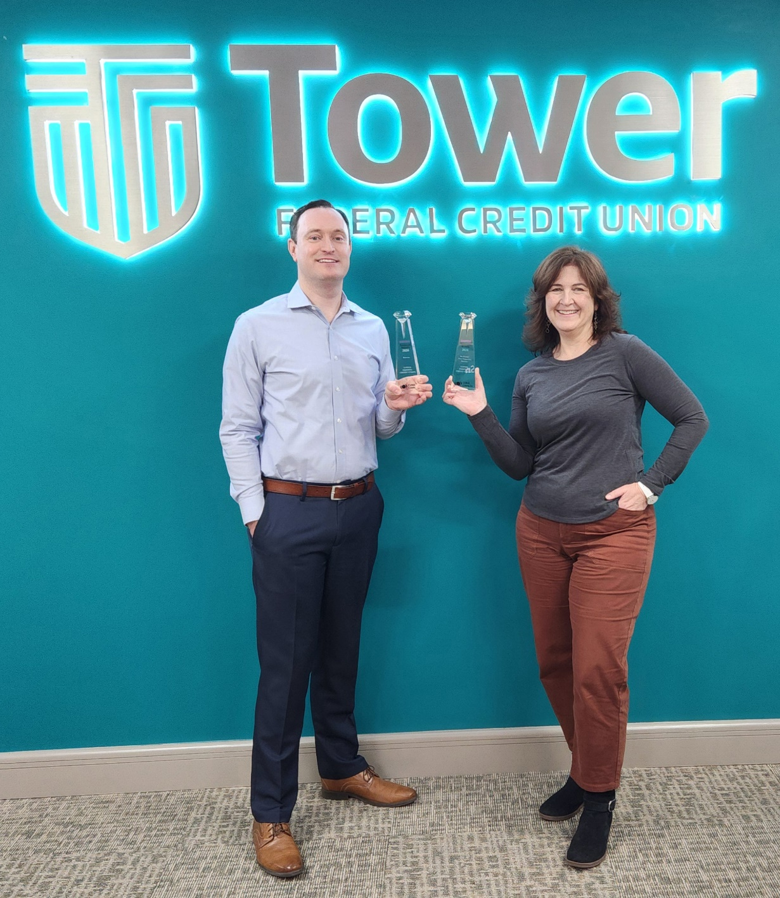
PHOTO CREDIT: Tower Federal Credit Union
PHOTO CAPTION: Tower Federal Credit Union was recently honored with two Diamond Awards from the CUNA Marketing & Business Development Council of America’s Credit Unions. Tower won in the Rebrand/New Corporate Identity category for its recent brand refresh and in the Website category for its website redesign. The Diamond Awards are the most prestigious annual credit union industry competition and represent the best credit union marketing campaigns of the year. Pictured with the awards are Tower’s Tom Poe, VP/Director Marketing & Business Intelligence and Renee Daley, AVP Creative Brand Services. To learn more, visit towerfcu.org.

###

About Tower Federal Credit Union
Tower Federal Credit Union is a member-owned, non-profit financial institution with headquarters in Laurel, MD. Established in 1953, Tower is one of the largest federal credit unions in Maryland with over $4.5 billion in assets. We provide a full array of financial products and services for our more than 225,000 members worldwide. We serve our local-area members with 12 branches in Anne Arundel, Baltimore, Howard, and Prince George’s counties and three branches at Fort Meade, as well as online services and digital banking at towerfcu.org.

About America’s Credit Unions
America’s Credit Unions is the unified voice for not-for-profit credit unions and their more than 140 million members nationwide. America’s Credit Unions provides strong advocacy, resources and services to protect, empower and advance credit unions and the people and communities they serve. For more information about America’s Credit Union, visit AmericasCreditUnions.org.

