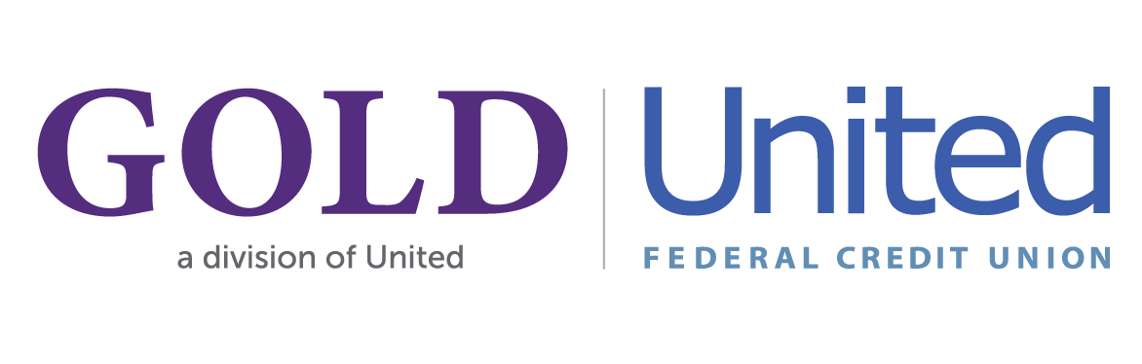

United Federal Credit Union – Press Release
March 22, 2024

Contact: Matt Orlando
Phone: (888) 982-1400 ext. 1473
Email: morlando@UnitedFCU.com
United Federal Credit Union, 150 Hilltop Road, St. Joseph, Michigan, 49085

GOLD Credit Union Members’ Positive Vote Finalizes
Merger Approvals with United Federal Credit Union

ST. JOSEPH, Mich. – Pennsylvania-based GOLD Credit Union (GOLD) expects to officially merge into Michigan-based United Federal Credit Union (United) on Monday, April 1, 2024 following an approved vote by GOLD members on March 21.

The two credit unions announced their plans to unite in November 2023, and regulators approved the merger in December 2023.

GOLD’s two locations in Allentown will remain open, operating as a division of United. Employees at these locations will remain in place, including current GOLD CEO, Cheryl Bartholomew, who will serve as Community President for United in Pennsylvania.

“Joining United Federal Credit Union is going to have a great impact on the financial futures of our members as they’ll soon have access to the products and services they have been asking for over the years,” said Bartholomew. “I am looking forward to the evolution of our commitment to supporting the Lehigh Valley as United Federal Credit Union, while maintaining the same values, resources, talent, and community spirit this area has come to expect from GOLD.”

Over the next several months, work will begin on a system conversion which will bring GOLD members’ information to United’s operating systems and give them access to United’s full suite of products and services. Meanwhile, the day-to-day experiences will remain the same until completion of the system conversion in early Fall 2024.

With the addition of GOLD, United’s total assets will exceed $4 billion, and approximately 10,000 GOLD members will join the credit union bringing its membership to more than 194,000.
____________
About United
United Federal Credit Union has served its Members since 1949 by helping them to build a sound financial future. United consists of more than 194,000 Member/owners worldwide and manages assets in excess of $4 billion. Its corporate office and main branch are in St. Joseph, Mich., with additional branches in Arkansas, Indiana, Michigan, Nevada, North Carolina, Ohio and Pennsylvania. Federally insured by NCUA. Equal opportunity lender. Equal housing lender. For more information visit UnitedFCU.com

# # #

