

**United Federal Credit Union – Press Release**

April 30, 2024

Contact: Matt Orlando, Public Relations Manager

Phone: (888) 982-1400 ext. 1473

Email: [morlando@UnitedFCU.com](mailto:morlando@UnitedFCU.com)

United Federal Credit Union, 150 Hilltop Road, St. Joseph, MI 49085

**United Federal Credit Union   
Welcomes New Associate Board Member**

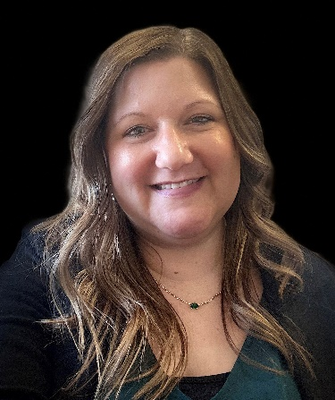Melissa Michael, Associate Board Member, Allentown, PA

**ST. JOSEPH, Mich. –** United Federal Credit Union (United) is pleased to announce the appointment of Melissa Michael as a new Associate Board Member. Michael brings decades of financial services experience to the volunteer role and will aid United in its mission to help members achieve their financial goals and to enrich the surrounding communities through service and philanthropy.

As an Associate Board Member, Michael will help guide the overall fiscal direction of the credit union and deliver strategic ideas that position United for continued success into the future.

“Melissa is an insightful and experienced credit union professional who will add immense value to our Board,” said United President/CEO Terry O’Rourke. “Her knowledge of and passion for the credit union industry, as well as her dedication to community impact and member success will only enhance United’s ability to achieve our growth and service goals.”

Michael joins United’s Board of Directors after serving nearly two years as a volunteer Board Member for GOLD Credit Union, which merged with United in April 2024. Currently, she is Vice President, HCM Solutions at CAI, a global technology services firm, in Allentown, Pennsylvania where she strategizes all global human resource operations from concept and design through to execution and implementation for all full-time and part-time employees and contractors.

Passionate about an inclusive workplace, Michael led the creation of CAI’s diversity, equity, and inclusion program that has seen engagement and success over the past five years. Employee-led resource groups are empowered to host many virtual and in-person events throughout the year that raise money and awareness for their respective communities.

She lives in Northampton, Pennsylvania and serves as a fundraising volunteer across various performing arts organizations.

**____________**

**About United**

United Federal Credit Union has served its Members since 1949 by helping them to build a sound financial future. United consists of more than 194,000 Member/owners worldwide and manages assets in excess of $4.0 billion. Its corporate office and main branch are in St. Joseph, Mich., with additional branches in Arkansas, Indiana, Michigan, Nevada, North Carolina, Ohio and Pennsylvania. Federally insured by NCUA. Equal opportunity lender. Equal housing lender. For more information visit [www.UnitedFCU.com](http://www.UnitedFCU.com)