



**Greater Texas|Aggieland Credit Union Earned Three Diamond Awards Amid Record-Breaking Competition**

**AUSTIN, April 9, 2024** – Greater Texas|Aggieland Credit Union received the prestigious honor of three Diamond Awards from the America’s Credit Unions [Marketing & Business Development Council’s](https://www.cunacouncils.org/content/cuna/councils/awards---scholarships/awards-programs/cuna-marketing---business-development-council-awards-programs/diamond-awards.html) annual marketing excellence competition.

The awards recognized:

* Greater Texas’ Little Lockers campaign, with a “category best” honor for its ongoing campaign to provide books and reading materials to elementary students within Manor ISD.
* Creative assets for Greater Texas|Aggieland’s GuidePoint internal knowledge-based learning platform.
* The Aggieland Credit Union subsidiary for its [Angler’s TV commercial](https://www.youtube.com/watch?v=nc8h7D0uIhY), which generated nearly 2,700 new checking accounts.

The Greater Texas|Aggieland campaigns were judged against a record 1,451 entries from 168 credit union organizations across the country.

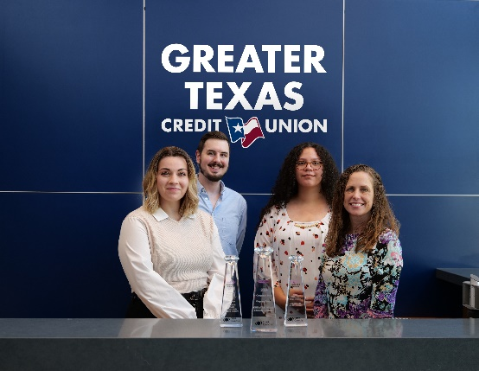“These awards highlight the achievements of a team that continually strives to excel in everything it creates,” said Sidney Henderson, Vice President of Marketing at Greater Texas|Aggieland Credit Union. “Every campaign we generate is an opportunity to make a difference for our employees, members, and the community.”

“We are delighted to honor Greater Texas|Aggieland Credit Union with this level of recognition,” said Lesli Bishop, Diamond Awards chair and Chief Marketing Officer at Family Savings Credit Union. “This credit union embodies the spirit of the credit union movement and propels it forward with its innovative marketing approaches.”

**About Councils:**

[Councils](http://www.cunacouncils.org) is a member-led, collaborative community of credit union leaders providing vibrant peer interaction, new ideas and innovation to foster professional development for executives while advocating for the overall success of the credit union movement. There are eight Councils with a network of more than 8,500 credit union professionals. The Councils are part of [America’s Credit Unions](http://www.AmericasCreditUnions.org)**.**

**About Greater Texas**

[Greater Texas](http://www.gtfcu.org) Credit Union, founded in 1952, is a financial cooperative that emphasizes community stewardship, charitable giving, and employee volunteerism through its Greater Good initiative. Together with its subsidiary, Aggieland Credit Union – which serves the Brazos Valley – the credit union offers a wide variety of consumer-oriented banking services to its 85,000 members across the state of Texas. Greater Texas has locations in Austin, Houston, San Antonio, Bryan-College Station, Edinburg, and the Dallas-Ft. Worth market with assets of nearly $1 billion.

###

Photo caption: Heidi Bancroft, Michael Easley, Awenetria McHorse, and Rachel Bond, are part of the Greater Texas|Aggieland Credit Union Marketing Team that had a role in creating the award winning campaigns honored with a Diamond Award from America’s Credit Union Marketing Council.