United Federal Credit Union – Press Release
April 18, 2024

Contact: Diana Wake
Phone: (888) 982-1400 ext. 6891
Email: dwake@UnitedFCU.com
United Federal Credit Union, 150 Hilltop Road, St. Joseph, Michigan, 49085

United Federal Credit Union Names New Mortgage Production Manager in Rogers

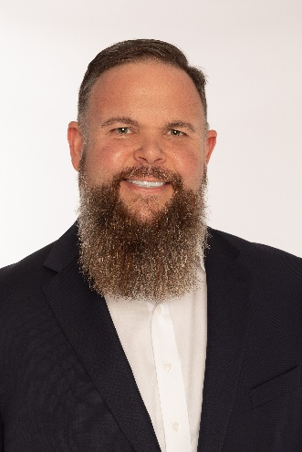
Jason Hedden, Mortgage Production Manager, Rogers

ROGERS, Ark. – United Federal Credit Union (United) is pleased to announce the appointment of Jason Hedden to Mortgage Production Manager. Hedden is based at United’s Promenade branch located at 2000 S. Promenade Blvd in Rogers, Arkansas.

Hedden will use his expertise to lead a team of Mortgage Advisors, provide quality real estate lending experience through financial counseling and product awareness to credit union members regarding their real estate financing needs, and generate investment quality mortgage loans.

“United took a big step forward with the addition of Jason Hedden to lead the mortgage team in the region,” said Andrew Clarkson, United’s Vice President of National Mortgage Production. “We look forward to the future as Jason will be instrumental to delivering our strategic plans in Arkansas."
Jason Hedden is a skilled mortgage professional with over 22 years’ experience in the financial industry. He pairs his industry knowledge with a passion to help people find the right mortgage option for their new home. Most recently, Hedden worked as the Vice President of Mortgage Lending at Chambers Bank.

"I am excited to join United and be a part of the great service and culture they bring to this industry,” said Hedden. “I look forward to sharing United’s "member first" focus and exceptional financial products with the greater Northwest Arkansas community."

____________
About United
United Federal Credit Union has served its Members since 1949 by helping them to build a sound financial future. United consists of more than 194,000 Member/owners worldwide and manages assets in excess of $4 billion. Its corporate office and main branch are in St. Joseph, Mich., with additional branches in Arkansas, Indiana, Michigan, Nevada, North Carolina, Ohio, and Pennsylvania. Federally insured by NCUA. Equal opportunity lender. Equal housing lender. For more information visit UnitedFCU.com
# # #

