



**Aggieland Credit Union Gives $10,000 to Texas A&M**

**RBI Campaign, Benefitting the RB Eye Foundation**

**Bryan-College Station, Texas, May 29, 2024** – Aggieland Credit Union upped the ante for the Texas A&M baseball team’s RBI campaign, benefitting the [RB Eye Foundation](https://www.rbeyefoundation.org/). The credit union gave a $10,000 matching donation to the campaign to motivate more Aggies to support this great cause.

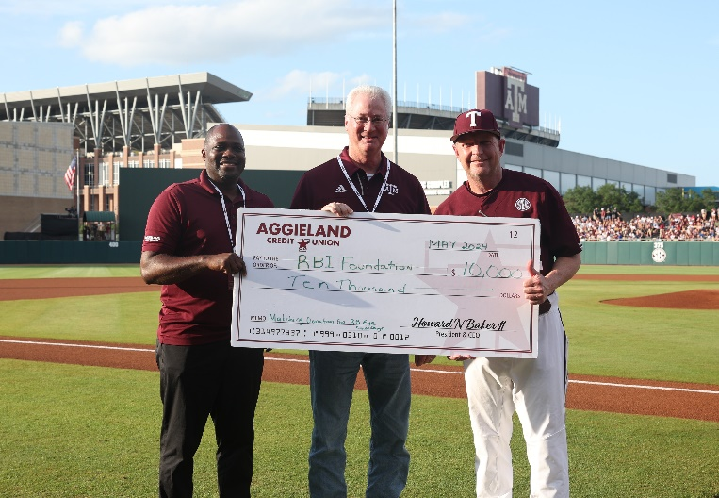Aggieland Credit Union is urging all Aggie fans to pledge to the campaign today to help Coach Schlossnagle’s foundation reach its fundraising goal of $100,000.

The RB Eye Foundation was founded by Schlossnagle after experiencing great difficulty finding treatments for his children when they were young and afflicted with Leber Congenital Amaurosis (LCA), the most common genetic cause of childhood blindness.

The RB Eye Foundation supports research organizations working to find treatments and a cure for LCA. The foundation also supports the Texas A&M Aggie Service Dog and Guide Dog program, which trains dogs to help visually impaired individuals.

[Pledges to the RBI campaign](https://pledgeit.org/aggie-rbis-for-rbeye-foundation) are based on the number of runs batted in that the Aggies accumulate this baseball season. As of the beginning of May the campaign had raised more than $18,000. Pledges can be as little as 25 cents per run and will be calculated based on the total number of runs for the entire season.

Pledges are made online and are calculated automatically throughout the season. Participants receive regular updates of their pledged contribution so they can monitor how well the Aggies are performing.

“Coach Schlossnagle’s foundation deserves everyone’s support, and we hope that this donation from Aggieland Credit Union motivates fans who haven’t pledged yet to sign on and join the effort,” said Jason McPhee, AVP of Strategic Partnerships and University Relations for Greater Texas|Aggieland Credit Union.

McPhee added, “The end of the A&M baseball season will bring the RBI Campaign to a close, so we want to encourage all Aggies to make a pledge today.”

**About Aggieland Credit Union**

[Aggieland Credit Union](http://aggielandcu.org/) was founded in 1985 by Aggies as a financial cooperative to support fellow Aggies and their families. The credit union is now a subsidiary of Austin-based Greater Texas Credit Union and emphasizes community stewardship, charitable giving, and employee volunteerism. Together with Greater Texas, Aggieland Credit Union offers a wide variety of consumer-oriented banking services to its 80,000 members across the state of Texas. The combined credit union has locations in Bryan-College Station, Austin, Houston, San Antonio, Edinburg, and the Dallas-Fort Worth market with assets of nearly $1 billion.

###