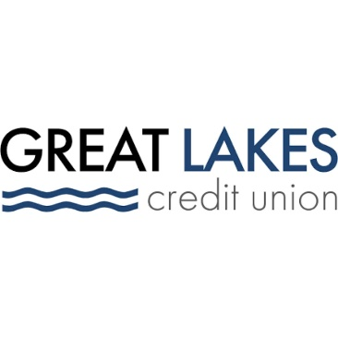
www.glcu.org

FOR IMMEDIATE RELEASE | Contact: Media Department  MarketingDepartment@glcu.org
Encurage Financial Network Credit Union Members Vote in Favor of GLCU Merger, Legal Day 1 Upcoming
Chicago, Ill. (May 29, 2024) –
On May13, encurage financial network credit union (EFNCU) members voted in favor of the upcoming merger with Great Lakes Credit Union (GLCU). EFNCU members will become members of GLCU on June 1, 2024, which is the official merger date. The combined organization will operate under the unified brand name of Great Lakes Credit Union, while SEG-based branches will utilize a co-branded approach.
The partnership will provide EFNCU members with a wider range of financial products and services, as well as a larger branch network, advanced digital banking technology, and access to financial education and counseling services through the GLCU Foundation for Financial Empowerment.
The two organizations originally announced their intent to merge in January 2024. GLCU and EFNCU chose to merge based on their mutual dedication to their members, employees, communities, and a shared vision for the future.
“GLCU and encurage have always prioritized member service, leadership, and community involvement. Together, we’re poised to amplify our impact and offer more to our members and employees,” said Steve Bugg, president and CEO of Great Lakes Credit Union.
“The merger is a true partnership that will bring our members new benefits and services, increased convenience, and a larger community impact. We’re excited to embark on this new chapter together with GLCU,” said Michael Abraham, CEO of EFNCU. Upon closing, Abraham will become the Chief Strategy Officer of Great Lakes Credit Union.
encurage financial network brings more than 14,000 members, mostly in the greater Chicagoland area, and more than $200 million in assets to the new organization to combine with GLCU’s 80,000 members and $1.3 billion in assets. The combined entity will serve 94,000 members and hold approximately $1.5 billion in assets.
Great Lakes Credit Union
Founded in 1938 and headquartered in Northern Illinois, Great Lakes Credit Union is banking for a greater good. As a not-for-profit financial cooperative with over $1.3 billion in assets, GLCU is proud to serve 80,000 members in Chicagoland and surrounding areas, and to give back to its members and communities through education, volunteerism, and partnerships. Learn more about GLCU’s accounts, educational initiatives, and community development programs at www.glcu.org.
encurage financial network credit union
encurage financial network credit union was formed in 2023 to provide collaborative solutions for the members of four small asset-size credit unions with legacies extending back as far as 1936. encurage has steadily expanded and grown, serving over 14,000 members and holding over $220 million in assets.

